**Facebook image size guide**

This guide gives the lowdown on the best image sizes for Facebook. This guide was last updated in May 2024.

This includes:

* Timeline (feed) images
* Profile Image
* Cover Images (personal, business page, and Event)

## **Timeline (feed) Images**

* 1200 x 630 px is the minimum image size to keep your images looking crisp. We most often use 1200 x 1200 px square images.
* Facebook allows most image sizes/aspect ratios to be uploaded - so long as it’s not too tall and narrow, or too short and wide.
* Square or portrait images allow for more height, i.e. more area on-screen as the user scrolls through their feed.
* To maximise the height and space occupied in the timeline, upload an image in portrait orientation (vertical) that is in the ratio of 3:2.

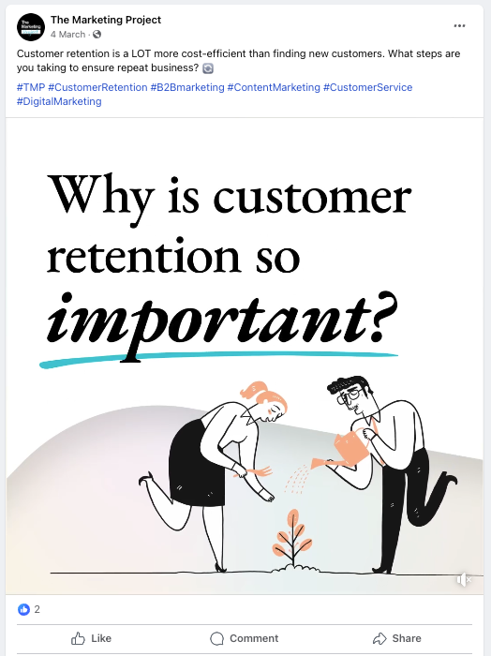

## **Profile Image**

* The profile image can be a JPG or PNG.
* The image will be compressed when uploaded to 170 x 170 px (128 x 128 px on smartphones) when displayed on the Profile page:

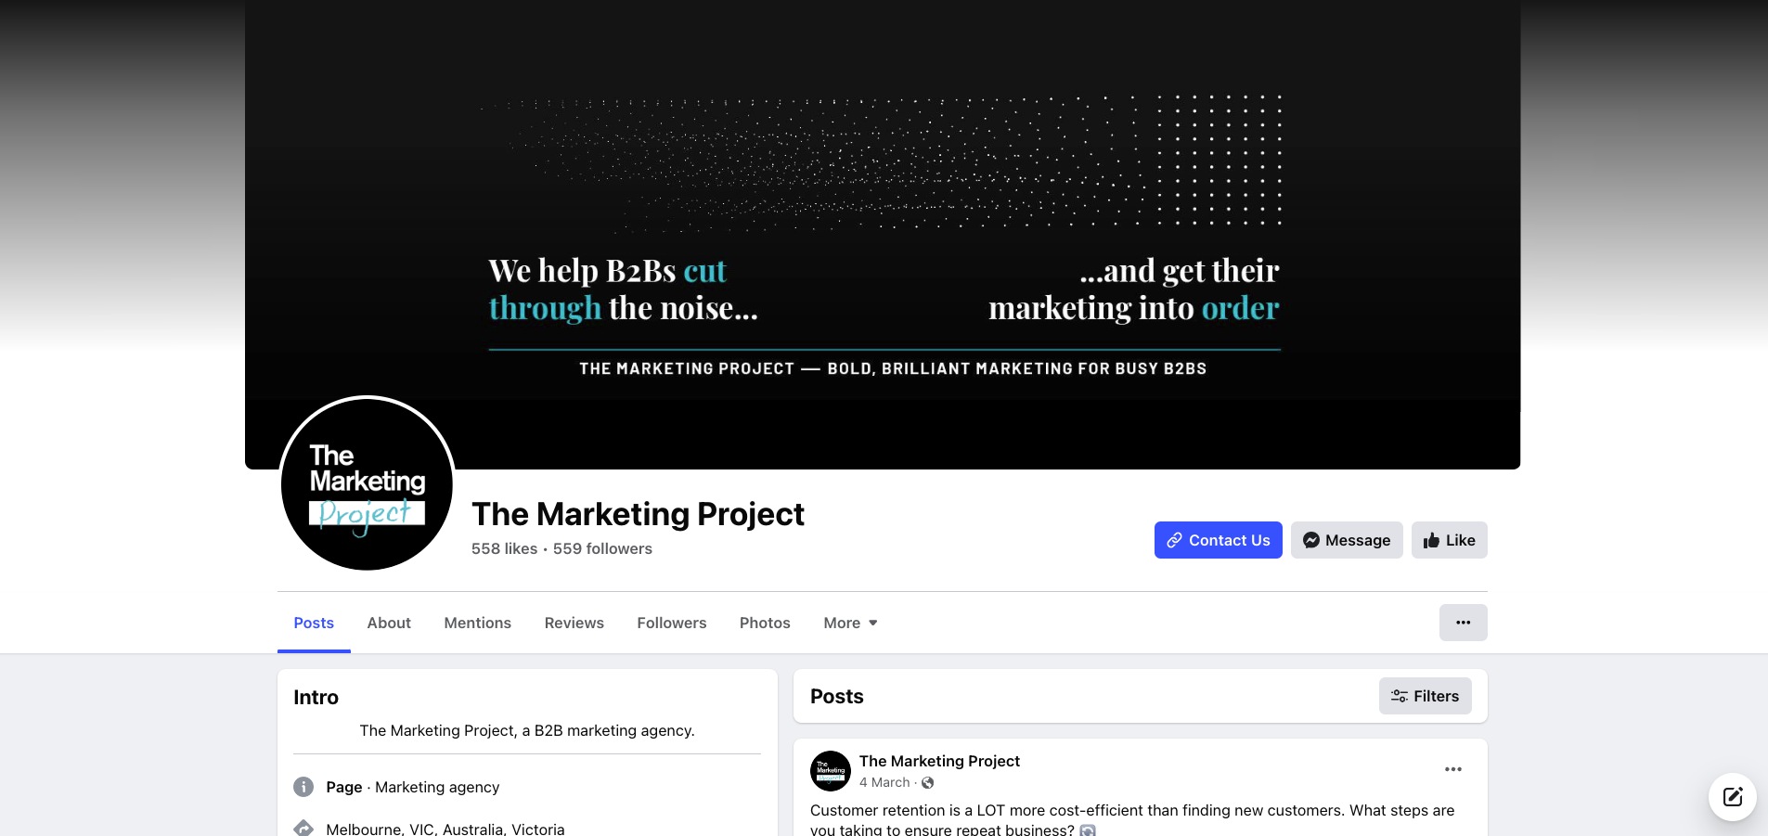

* For best results use a larger, sharper original image. We usually use 850 x 850 px, so it will appear nice and large when clicked.
* The profile image will crop to a circle when viewed in the feed – so it’s important to consider how it will appear. Avoid placing important visual information in the corners, and if your design is circular (e.g. a circular logo) – make sure its edges sit on or within Facebook’s circular crop.
* When in the feed, the profile image appears even smaller at just 40 x 40 px, so consider legibility, especially on small screens. If your image or logo is quite detailed or busy – it might be worth considering a “simplified” or icon version of the logo for your profile image.

## 

## **Cover Images**

### Profile Cover Image (individual user page)

* The cover image is displayed at **851px by 315px** (640 x 360 on smartphones). Again it’s best to upload a larger image to preserve as much detail as possible – we use **2037px by 754px**.
* Keep in mind the Profile image, along with some other page elements may obstruct parts of the image – so keep important visual information or text towards the centre of the image.

### Page Cover Image and Video (Business accounts and “Pages”)

* The cover image is displayed at 820 x 312 px. We upload a larger file – 1958 x 745 px.
* It can be tempting to use this large image as a billboard and place lots of text and detail there – but keep in mind this horizontal image scales down quite small on phones and may become unreadable.



* Videos are now permitted on Facebook – you can use the same dimensions to create a short, snappy video Cover instead of a still image. This can be great to show some large headlines over a few images – which will still retain legibility on smaller devices.

### Facebook Event Cover Photo and Video Size

* The profile cover image is displayed at 500 x 262 px. We recommend uploading a larger file – 1920 x 1005 px.
* This image will appear in a few places when pushed out to Facebook audiences – most notably the [**Events feed**](https://www.facebook.com/events/) page. The image will be displayed smaller here than on the event itself, so ensure text will remain legible in this view.

* Less is more, most details will appear in the text of the event, so you don’t need to squeeze too much into the header.
* Some cropping of the image occurs on Mobile devices – so keep important info away from the edges, towards the centre of the image.