How to create a PowerPoint template
This guide will take you through how to create a branded PowerPoint template, including custom typography styles and a selection of slide master options.

Customising the Master typography
Creating a branded cover page
Creating an internal page slide
Adding a section divider page
Final touches

Customising the Master typography
We’ll start by opening up a fresh PowerPoint slideshow as a base, from which we’ll be changing the default typography to our brand fonts.

For my example I’ll start with the black slate default – but PowerPoint now includes a good selection of other templates on the righthand side that you can also work from.

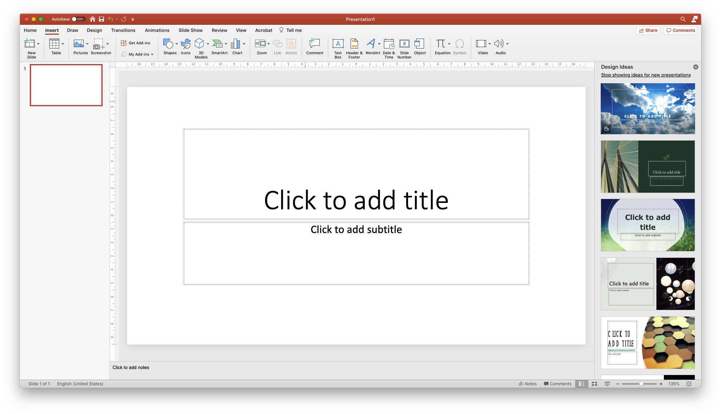

Next, we’ll view the Slide Master, under View > Master > Slide Master.
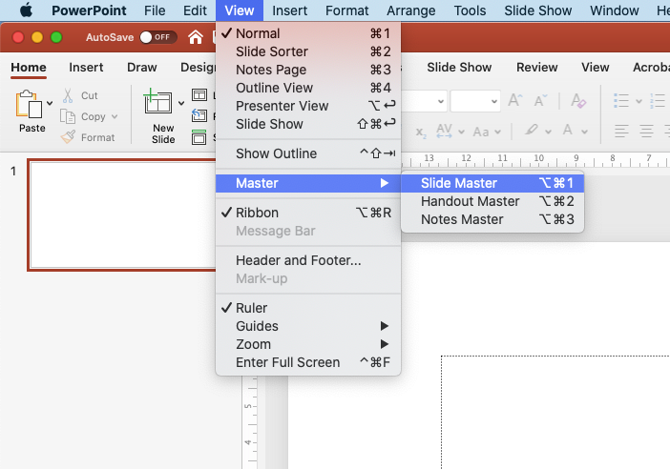

In the Master view, we’ll want to start with the top Master typography slide. This is the Master slide all others are based upon, so any typography changes we make will be applied to all of the below slides.

Note – the top Master typography slide affects the below slides, but it doesn’t work the other way. We’re free to change the typography styles further on the lower master slides without affecting any other slides, allowing for more creative possibilities.

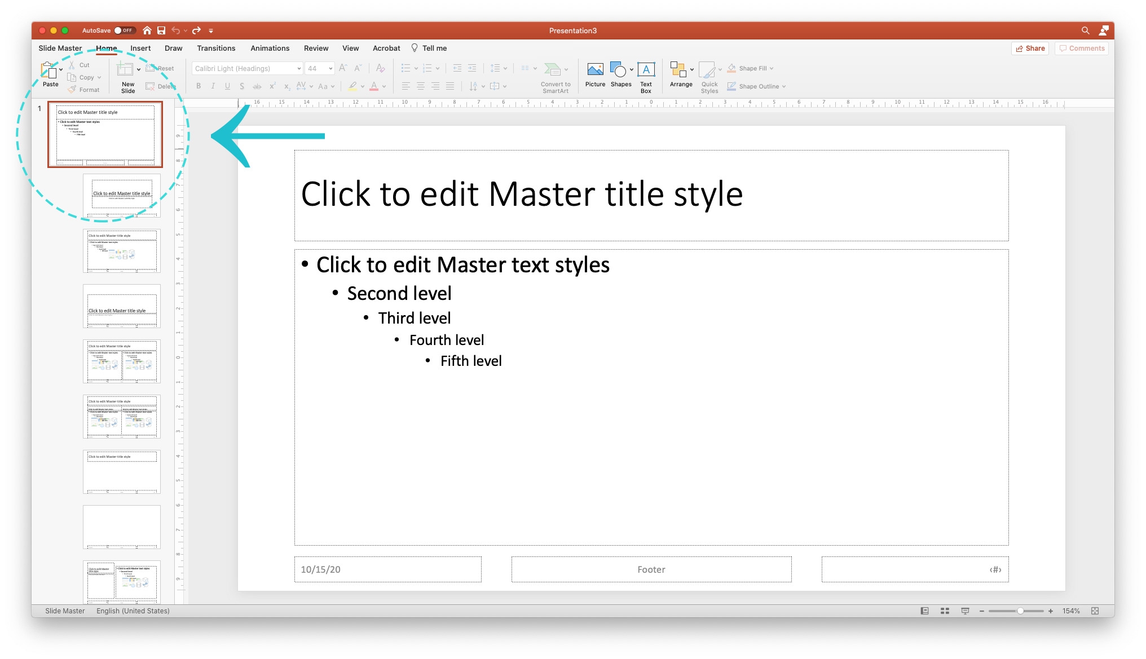

Start by selecting the heading…
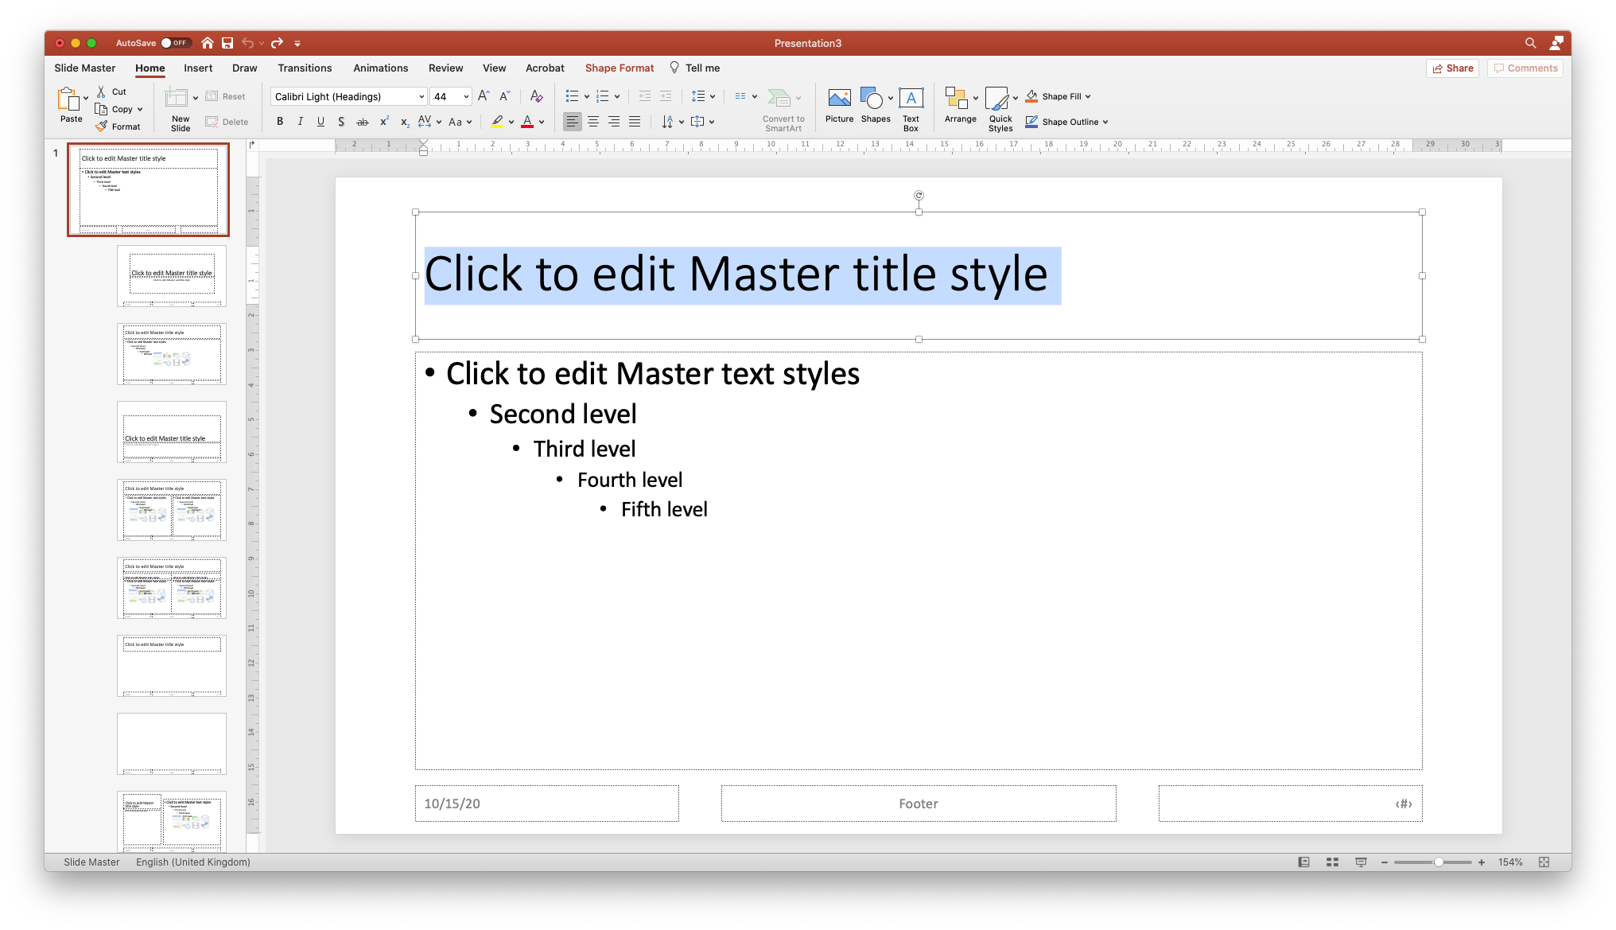

…and change the typography style to align with your brand title font. Here I’m using Barlow, a Google font.

Note! If you’re sending this PowerPoint file to other users (as a .ppt), it’s best to stick to system fonts (not fonts downloaded from the web). This will ensure your slides always appear consistently, and the user on the other end isn’t missing the required fonts in their document.

If you’re just saving to PDF and sending, other fonts are fine. These fonts will be embedded in the PDF and will appear the same no matter where they’re viewed.

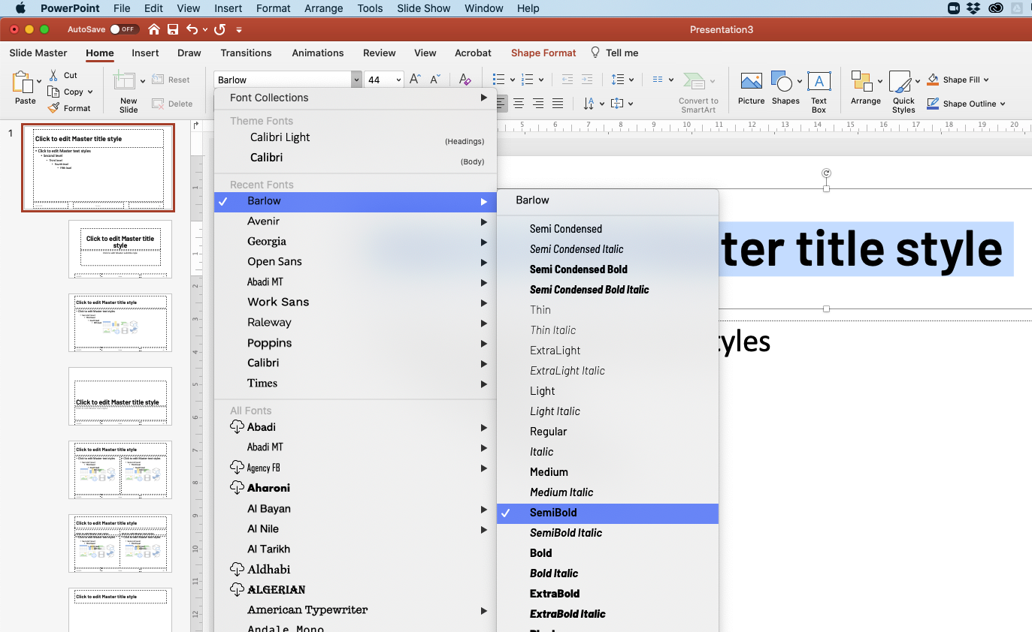

Continue down the page to customise all styles to your brand fonts. I’ve also changed the colours and bullet symbol for the top two bullet list tiers.

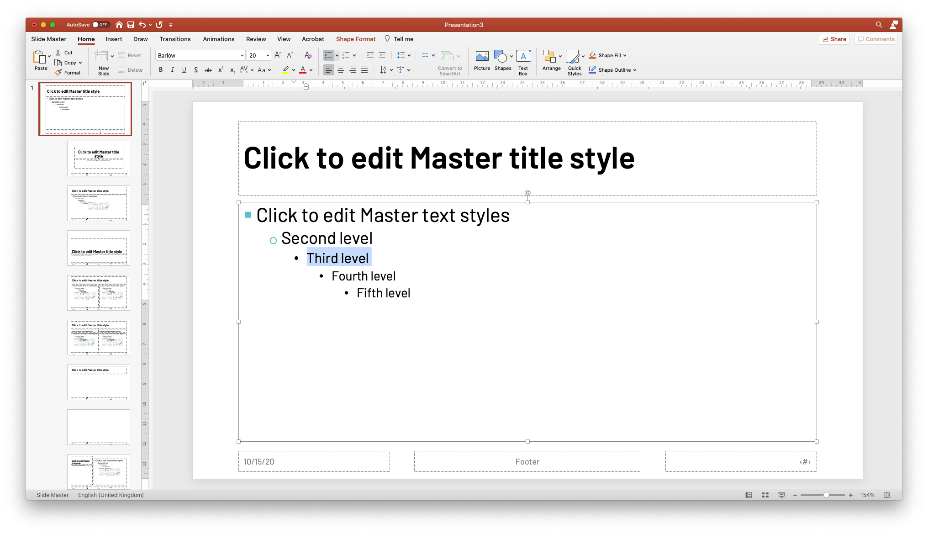

It’s okay if your slide is looking pretty bare-bones here – the focus here is mainly on the typography styles, not the slide design.

You’ll see your new styles have automatically been applied to the below slides.

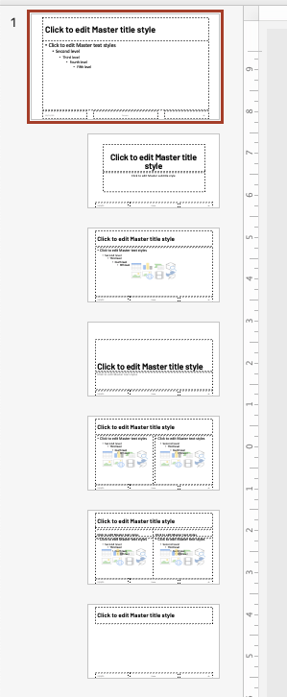

Creating a branded cover page
Using the Slide Overview panel on the left – jump down to the next slide in the Master.

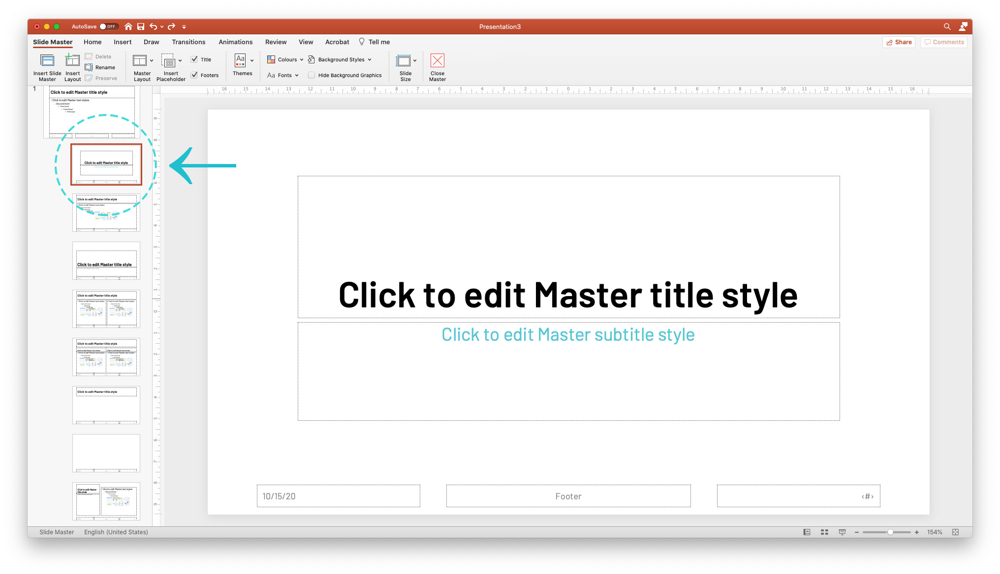

This is your title page, the first slide that will appear by default in all new slideshows.

The typography styles from the above typography slide looked pretty good here, I’ve just made the heading size a touch smaller, and changed the subtitle to TMP Teal.

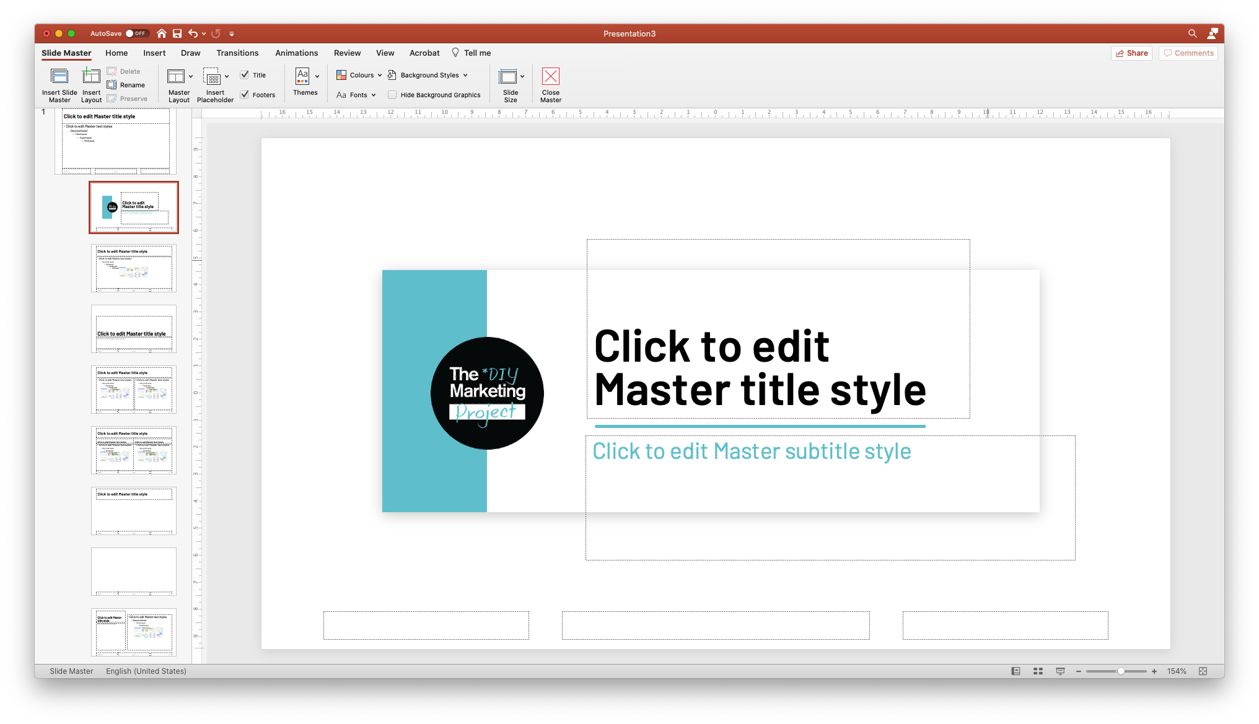

Next, I’ve brought in the TMP DIY logo, and added a couple of boxes and coloured elements to frame the title. I’ve also left-aligned the typography, putting the title over two lines which condenses the “title block” section I’ve created.
The intention here is to create a branded “frame” for my title, which is the most important element on the page.

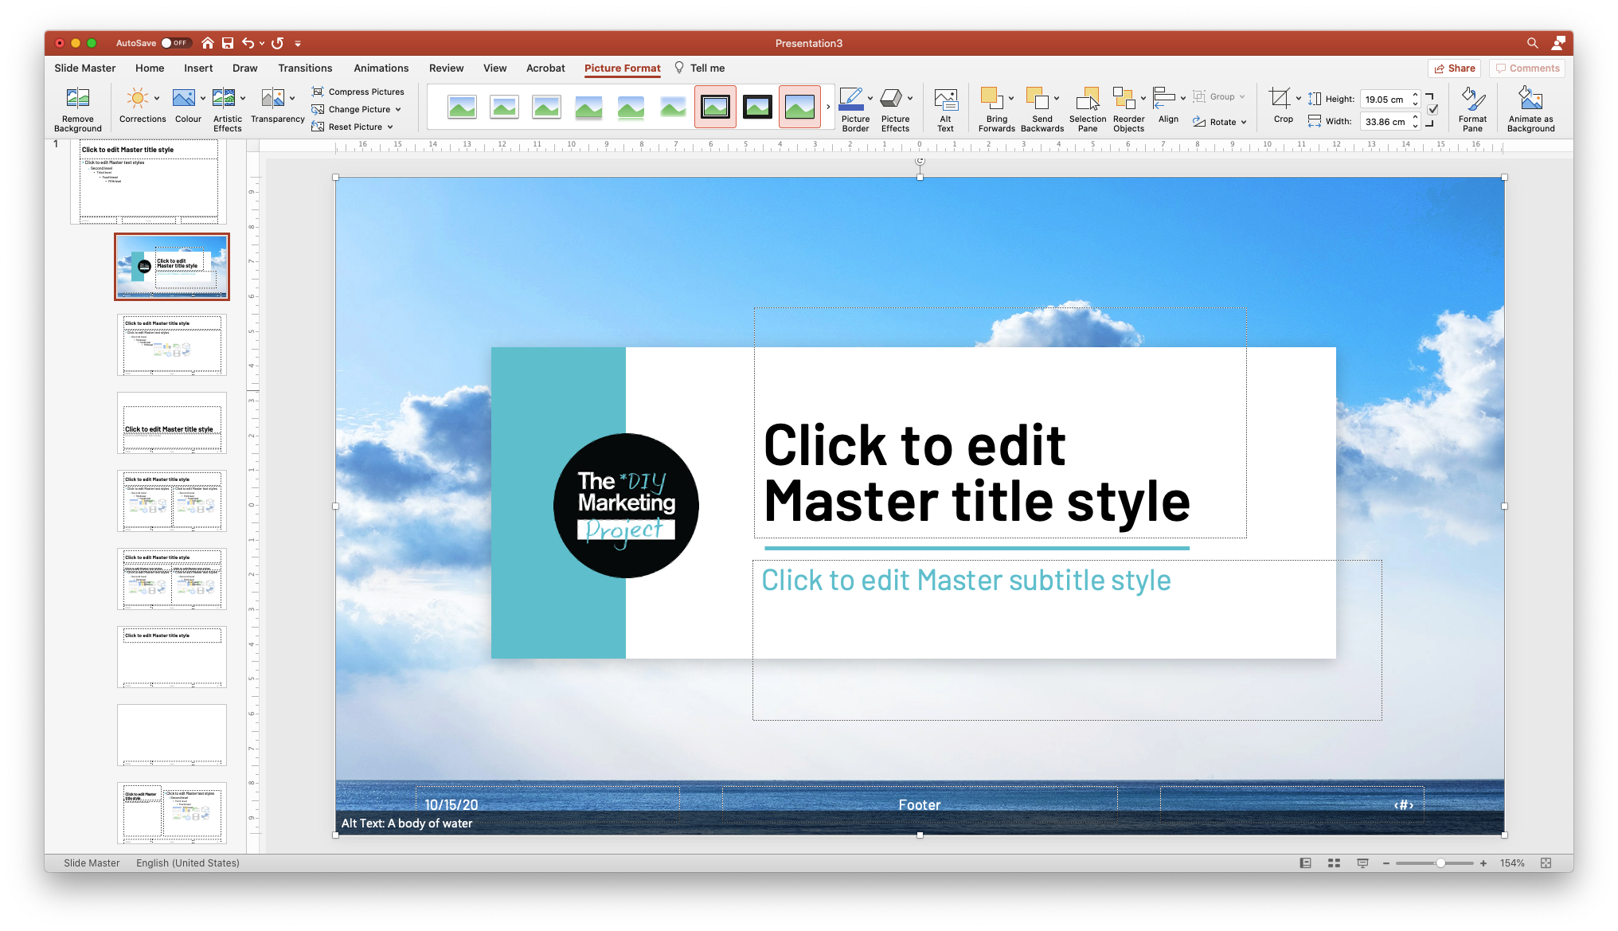

Next, I’ve added a background image. I’ve just dragged and dropped this 1920px by 1080px image in and Sent to Back – which will keep this easy for users to customise in case it needs to be replaced or removed.

I’ve also changed the footer content to white for better contrast on the image – you may need to invert the colours of some of the default typography styles depending on your layout.

Our brand colours, logo, and typography are all present and looking good – I’ve also chosen to overlay a brand pattern device that appears on other materials.

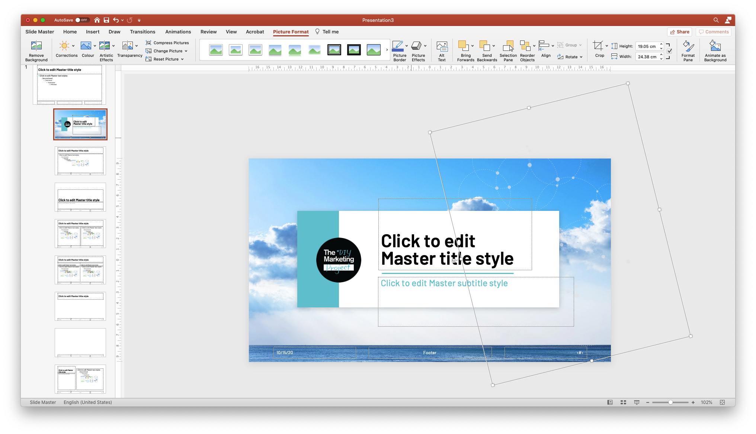

Creating an internal page slide
Next we’ll jump to the next Master down. This will be your Internal slide.

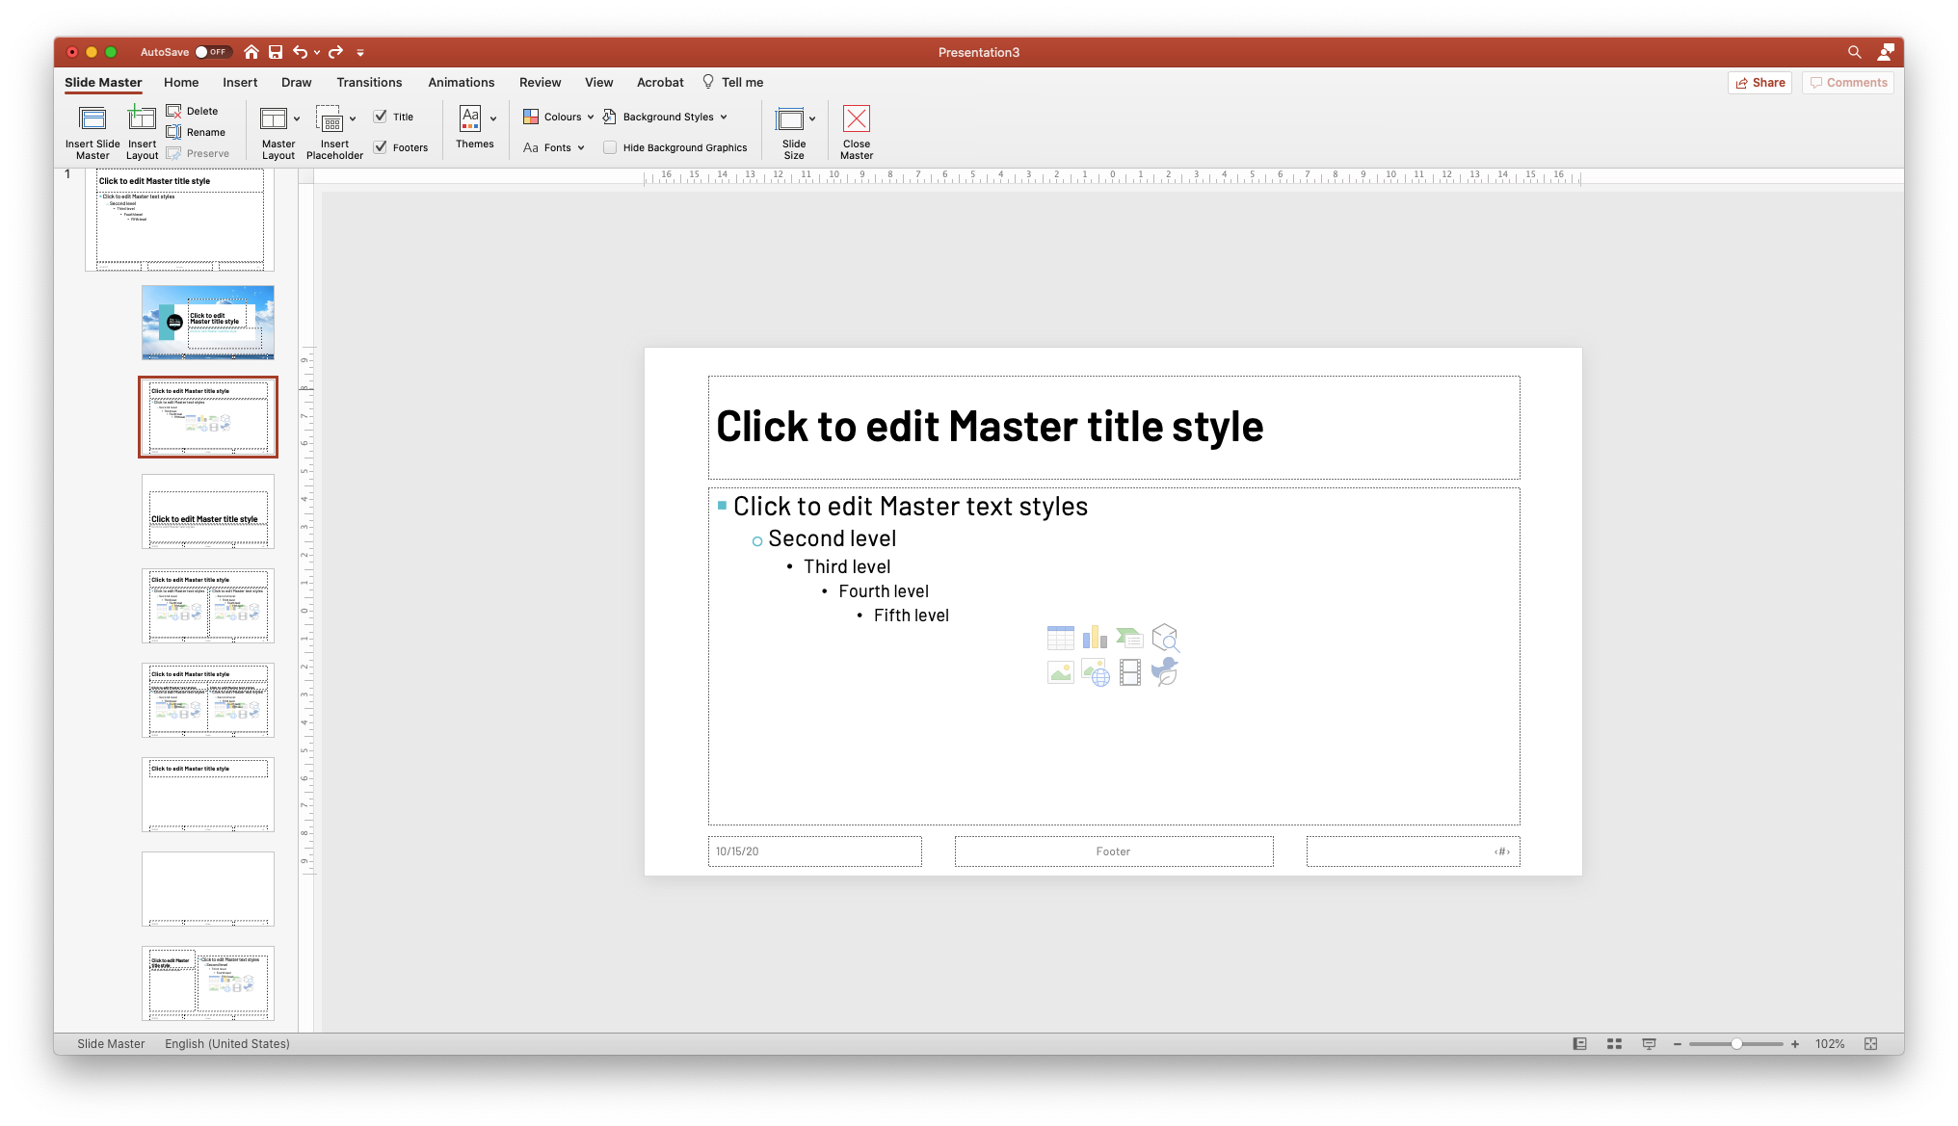

Here I’ve aligned all text left and reduced the size of the text area, so the section is more of a block, regardless of having a lot of text or just a little. I’ve also added another title underline to match the cover and repeated the brand pattern on the right-hand side.

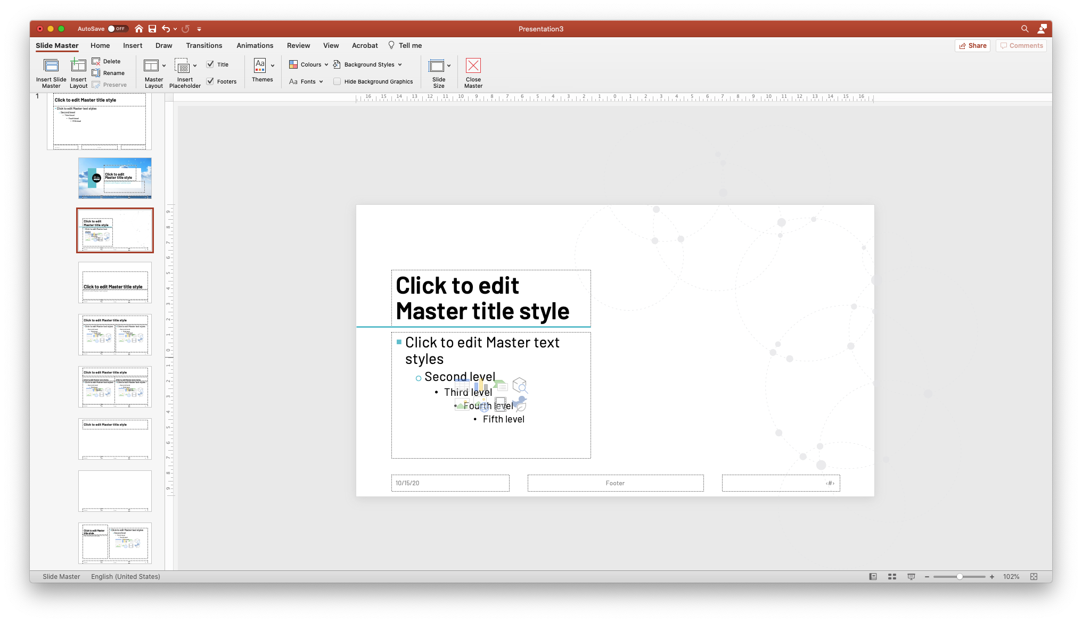

You could could add an image, diagram or more dot points in the white space on the right.

Adding a section divider page
Now that we’ve got a cover page and internal page sorted (along with the other below Masters that have automatically applied the new typography styles) – most PowerPoint users should be covered, however we could also add a section divider page to give this template a bit more flexibility.

This could also be used as an alternate cover page, or a thank you page at the close of the slideshow.

Skip down to the next Master in this slide section.

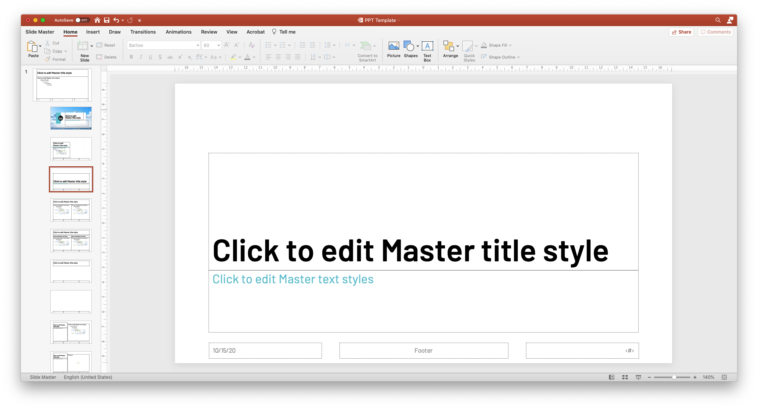

Again, you can make any edits to typography or design required to make this section divider stand out. Here I’ve inverted the title text to white, added the branded pattern as a transparent PNG overlay, and added a black box in the background.

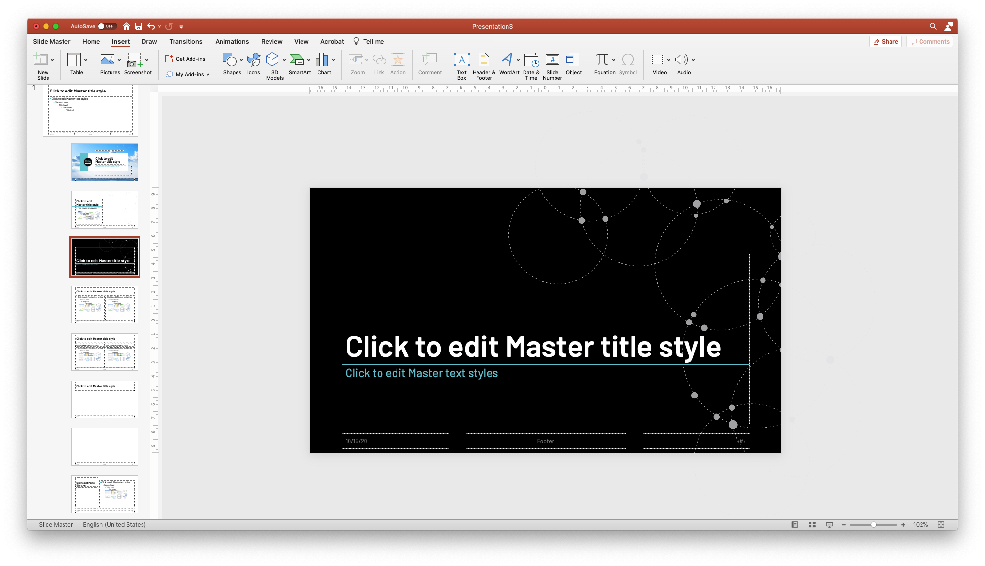

To keep my sky theme going, I’m also going to set this box to 80% opacity, so I can place a background image without affecting readability of the title.

To change transparency of a shape, select it and go to Picture Format > Format Pane > Transparency.

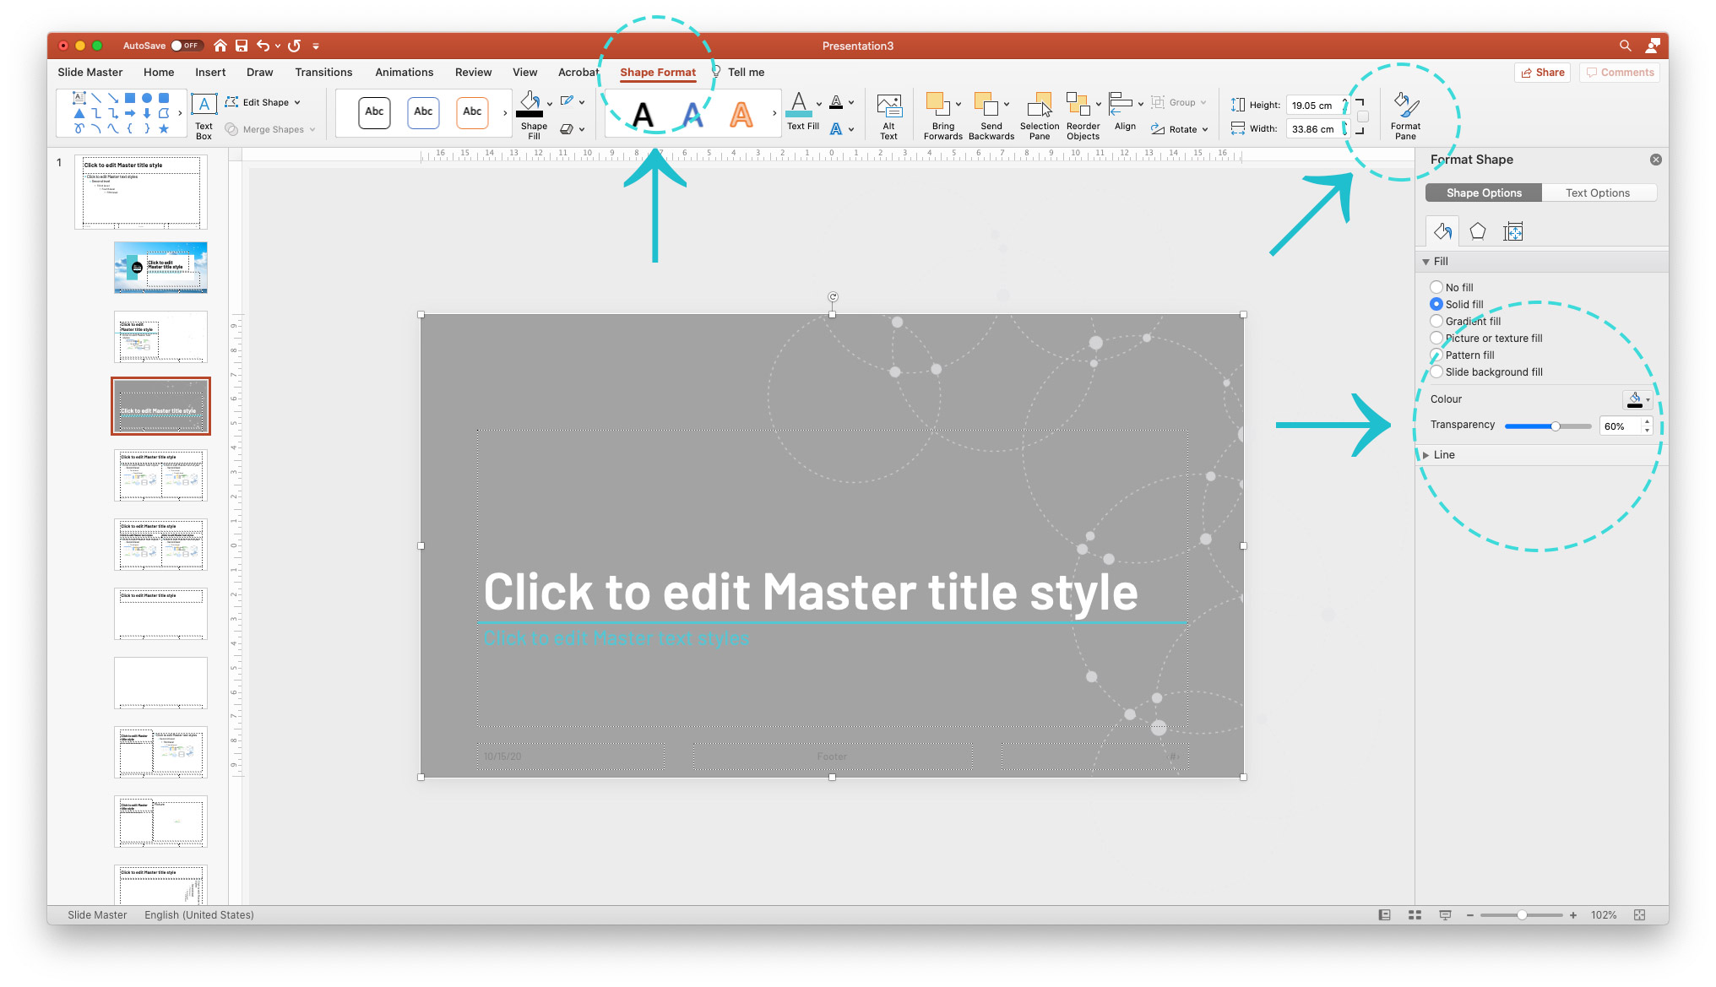

Next, we’ll drag and drop a background image into PowerPoint (sized in advance to 1920px by 1080px).

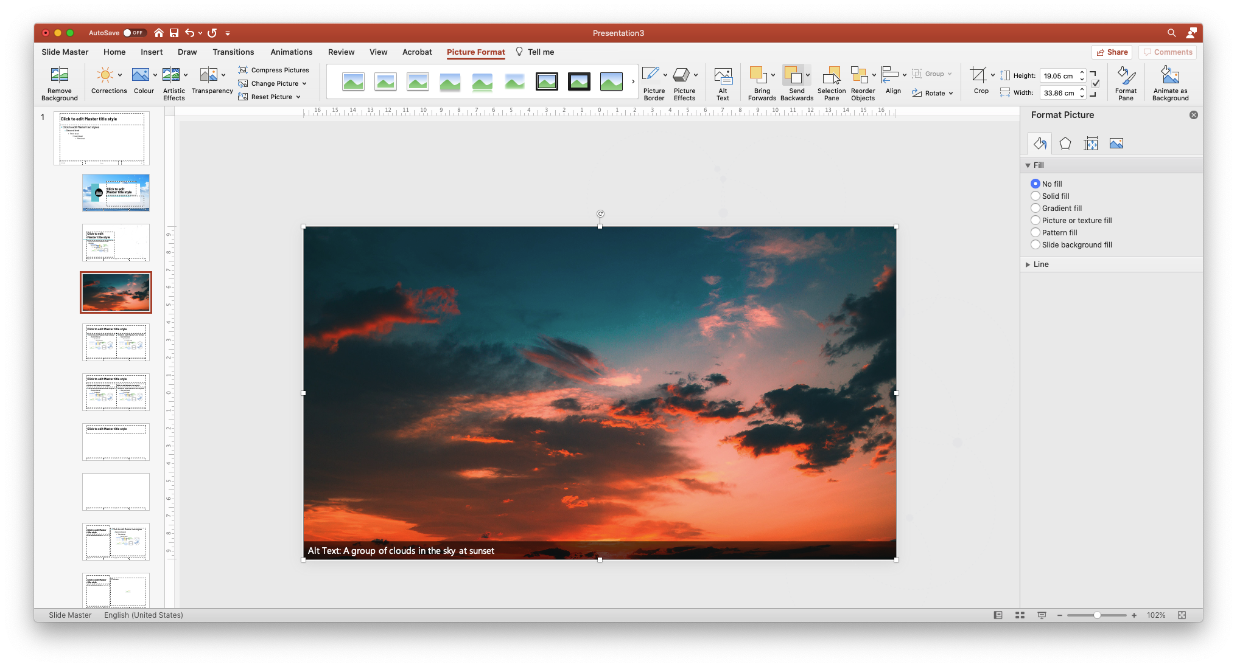

Send image to back, and your section divider page is done!
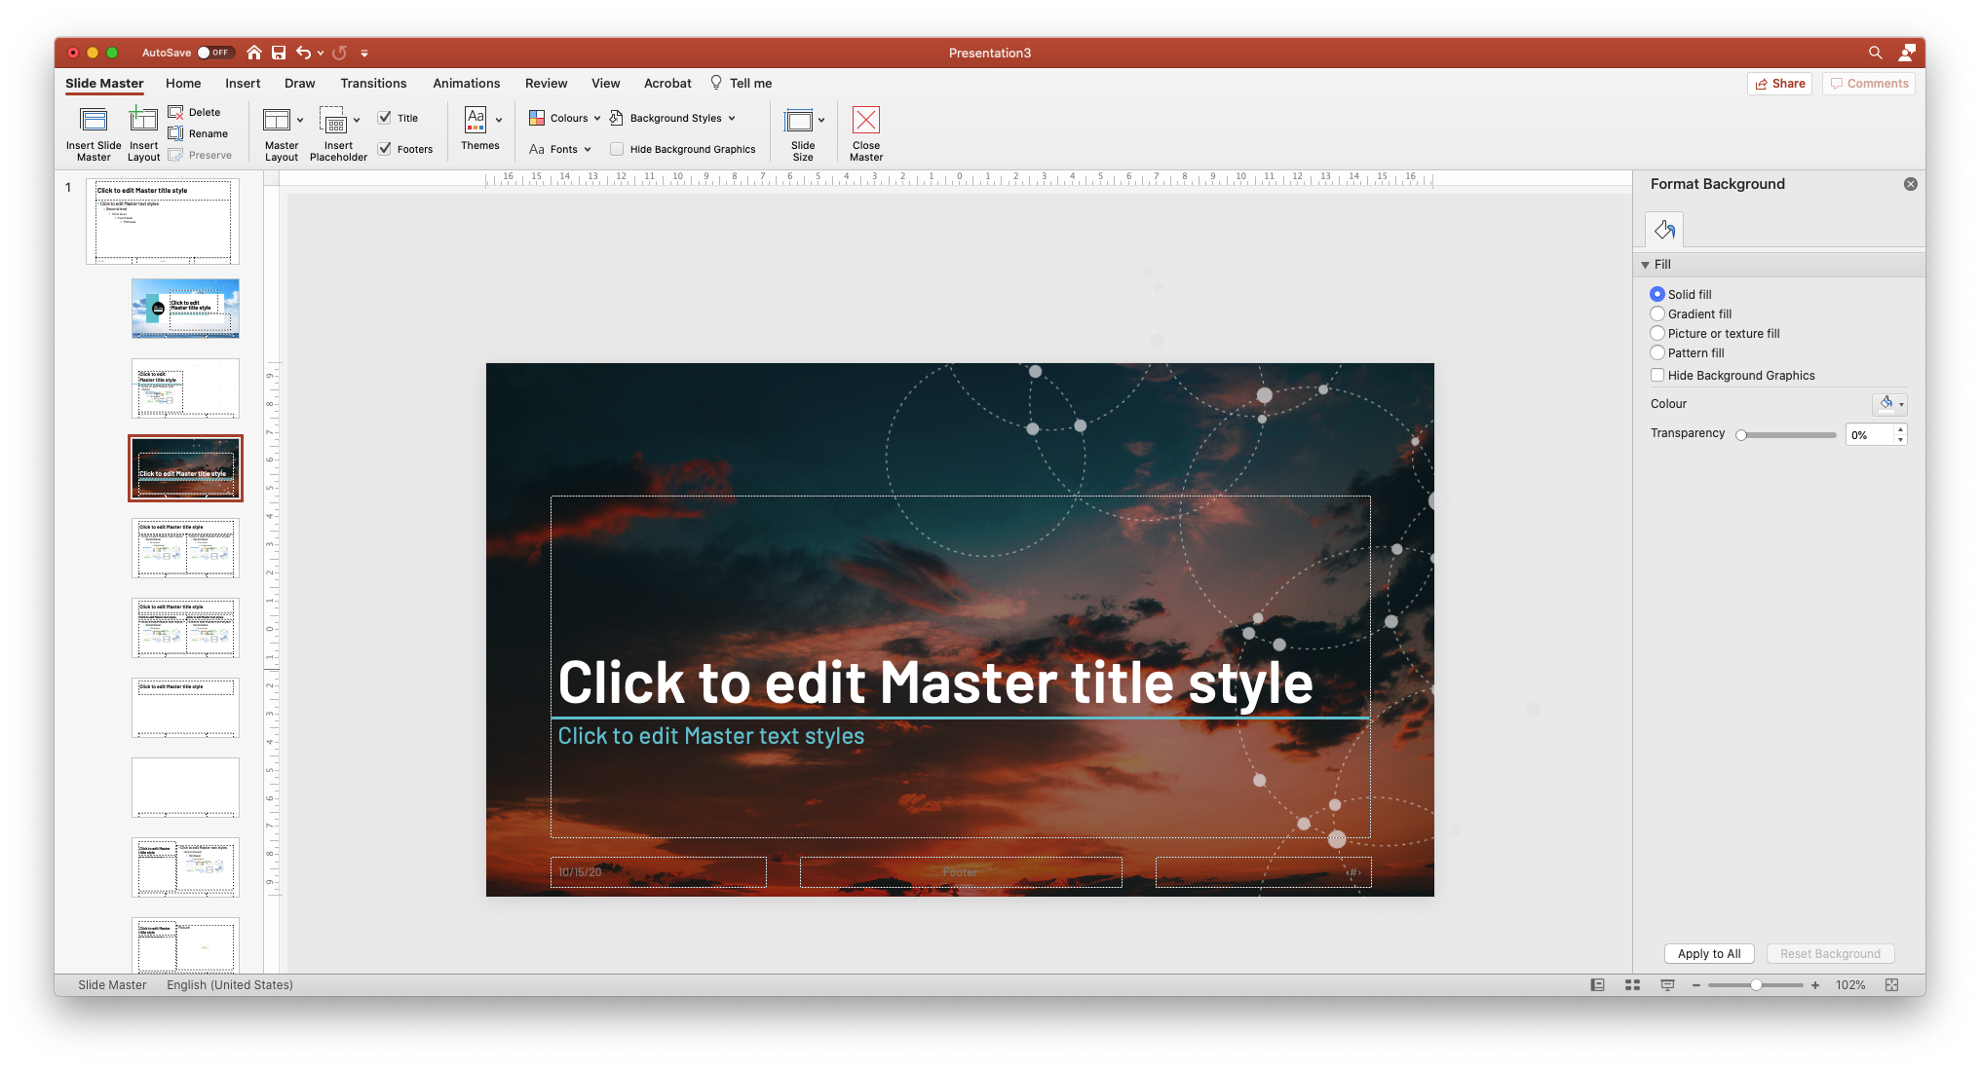

Final touches
The last few steps involved are setting up your template file for others to begin using.

Exit Master and return to the main slideshow view.

Add one example of each slide template by using the “Add slide” dropdown arrow.

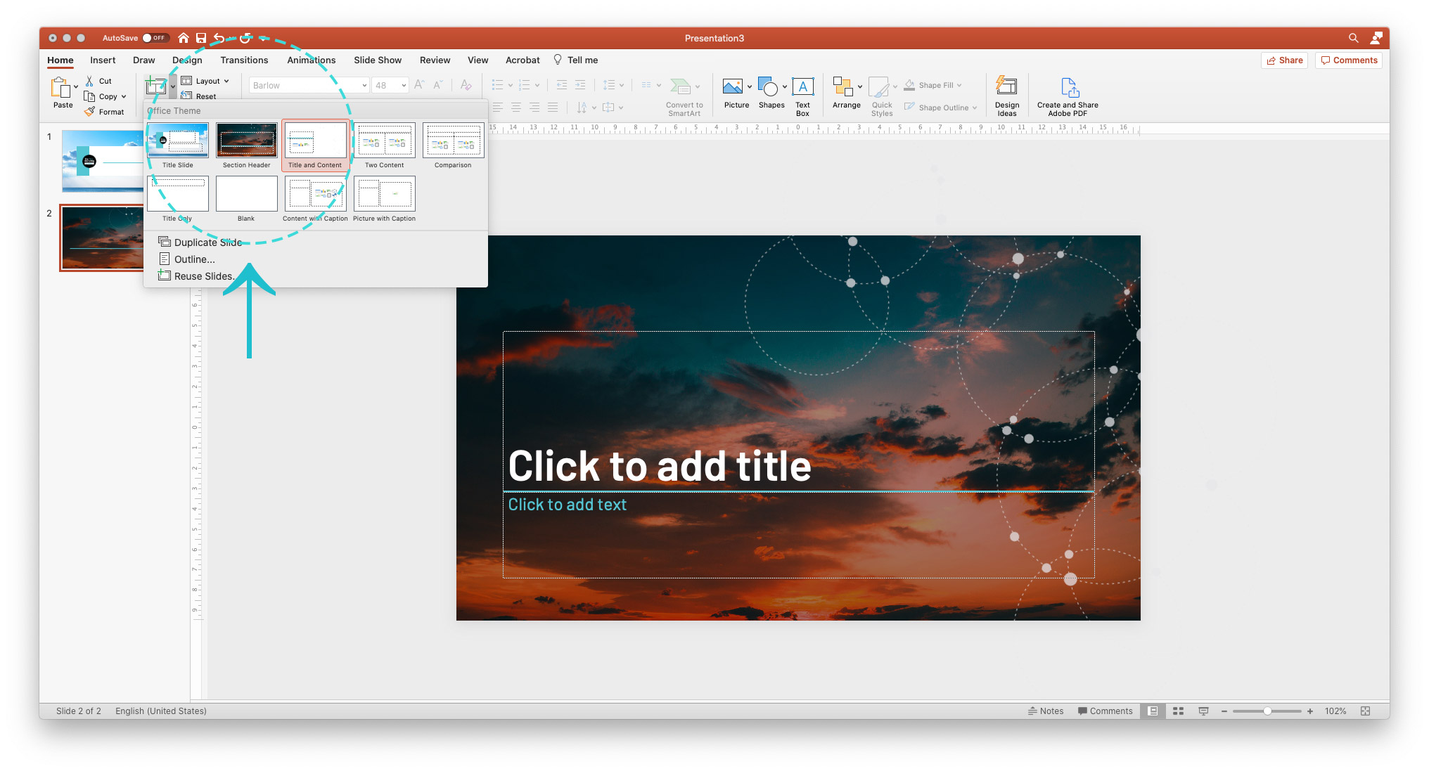

Add some example text in each, testing out each of your layouts to ensure they are ready for users to pick up.

On my Internal page layout, this involved me adding an example image.

This image can’t go in the Master otherwise it would appear on every slide using that Master, so it’s helpful for users to show where an image of their choosing might be placed on this slide design.

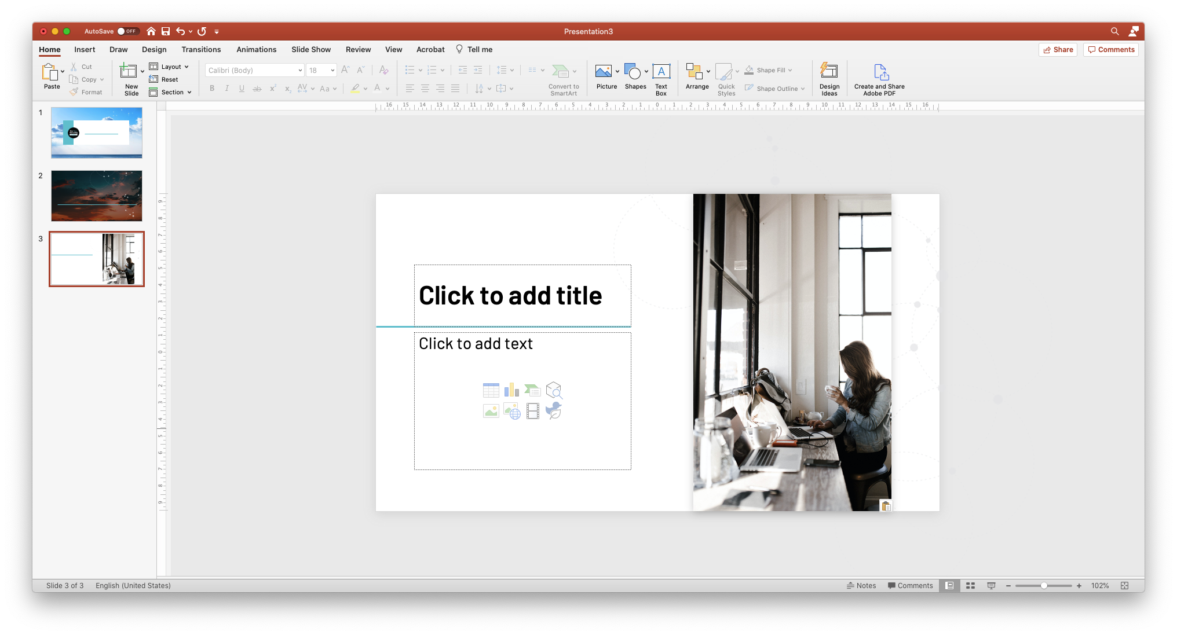

Once happy, save your PowerPoint as a .potx file. This is our read-only PowerPoint template file – users will always need to Save As which prevents it from being overwritten.

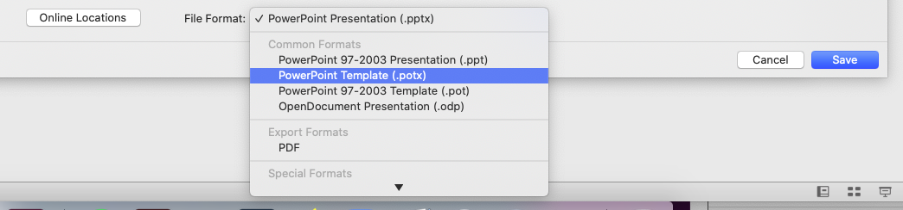

And you’re done! Happy templating!

