How to create videos with sub-titles
Learn below how to add sub-titles to a video file and how to upload the video to a LinkedIn profile.

Creating SRT Video captions
- Upload video to rev.com and request subtitles for video file (allow a one-day turnaround). If you don't have an account, you will need to set up one and follow the prompts.
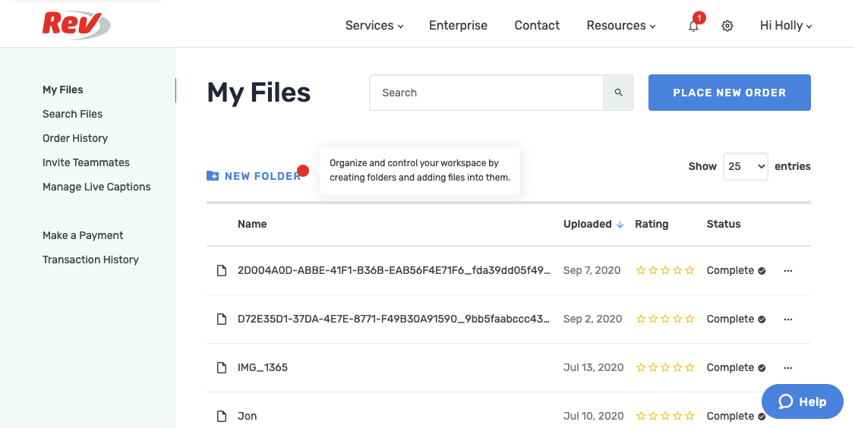
- To start the process, you will need to ‘place a new order’, click on the blue button and then select ‘Subtitles’.
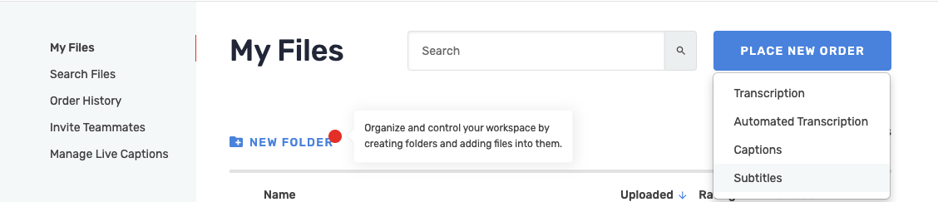
- Select between the upload options below.
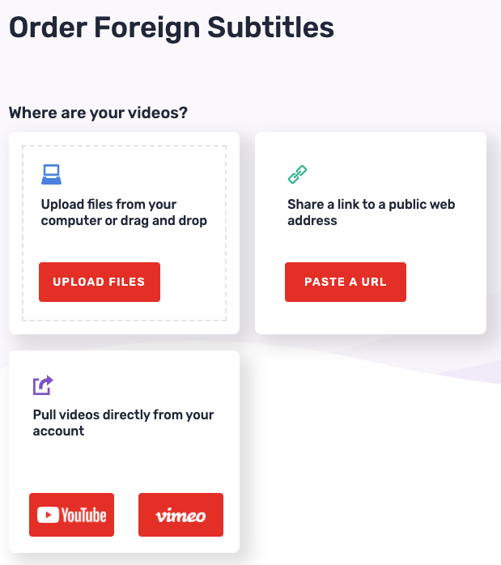
- Upload file or drag and drop into the below window, press upload.
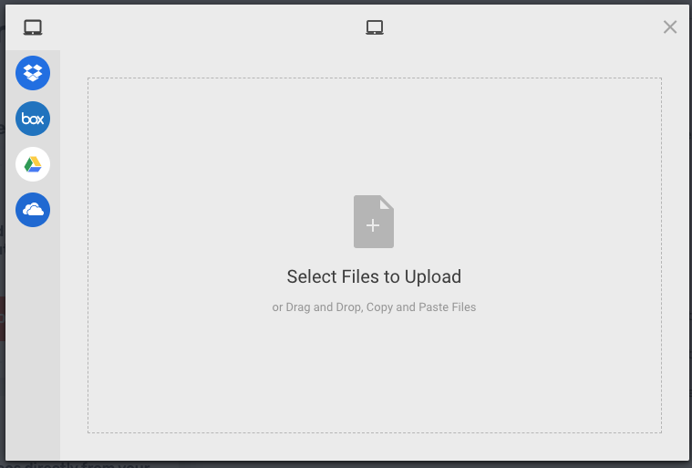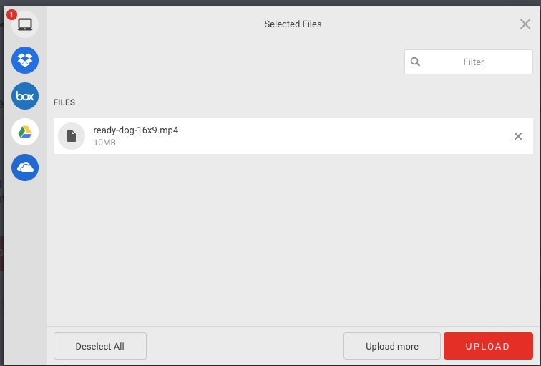

- Once the video has been uploaded you can follow the process through again by uploading more videos or you can continue on to checkout. It will ask you if you would like the video supplied in any additional languages. If you do, tick the relevant boxes. You will also need to make sure that the output format selected is an ‘SRT’ file. Then continue on to checkout and make payment.

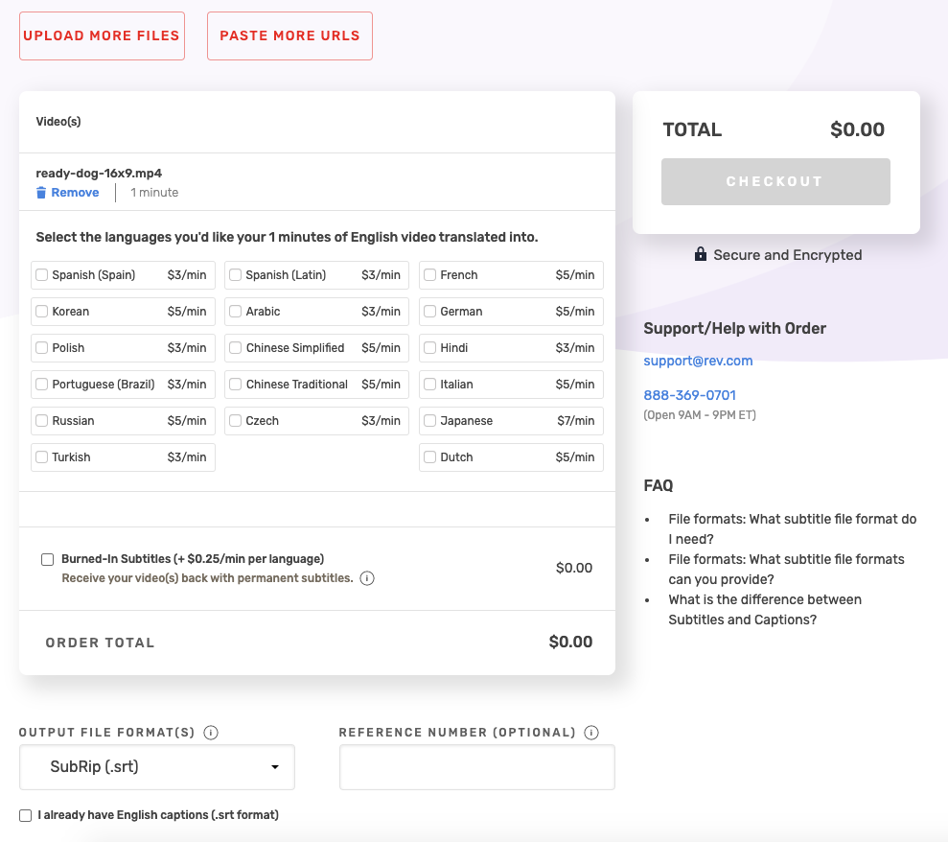

- The nominated email address will receive a notification email once the file has been created and is ready for review on the rev.com website.

- Log into rev.com, navigate to ‘My Files’ in the menu bar and locate your video, review the file for any typos or required changes.
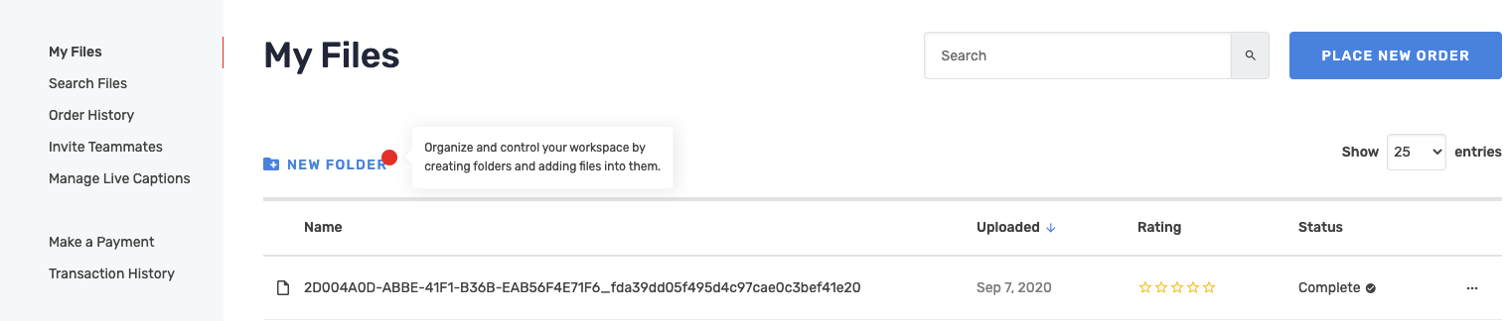
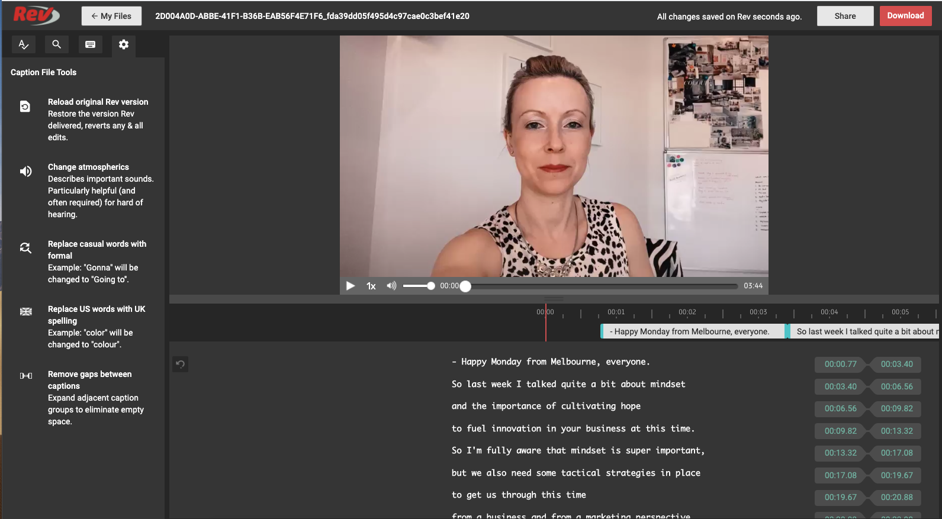

- Once you are happy with the file, click download. Ensure you have selected ‘SRT’ for the video format and save to computer.
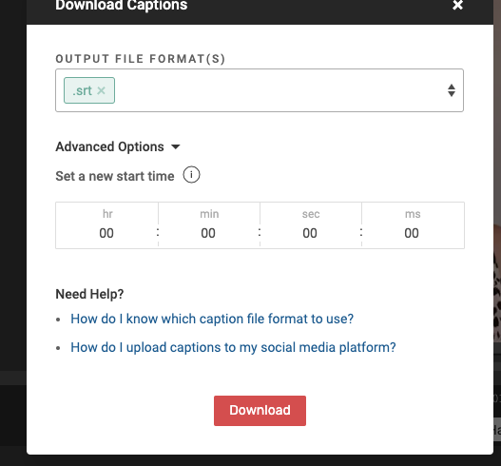

- Below is an example of a final SRT file, if you wish to view this you will need to open in ‘Text Edit’ program.
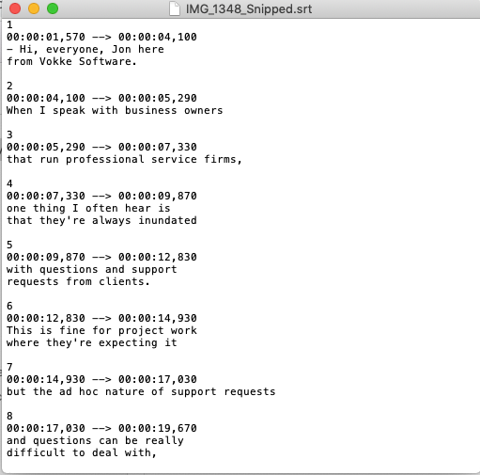

To upload to LinkedIn:
- Log into the LinkedIn profile.


- Go to start a post and click on ‘video’, a new window will appear. Select the video to share.

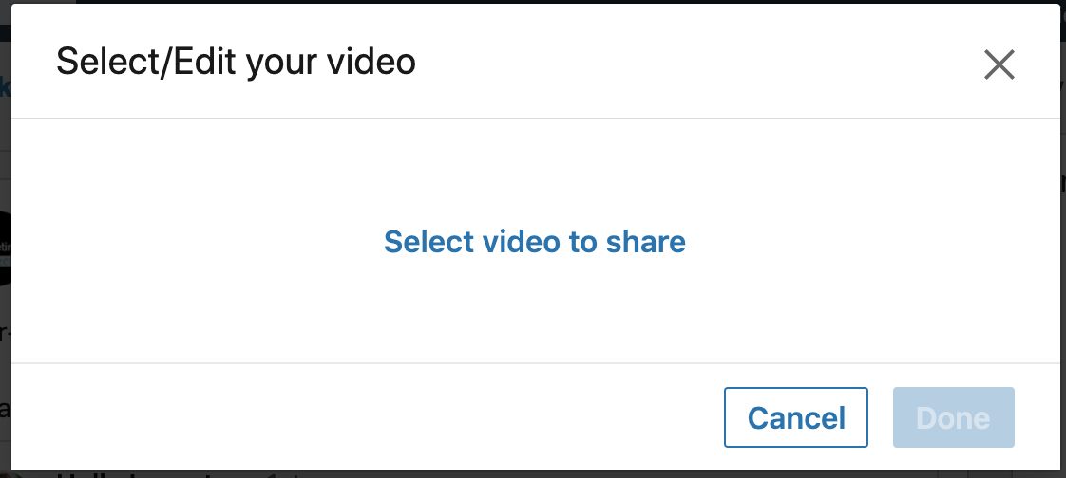

- Once uploaded, click on ‘Edit’ and a new window will appear.
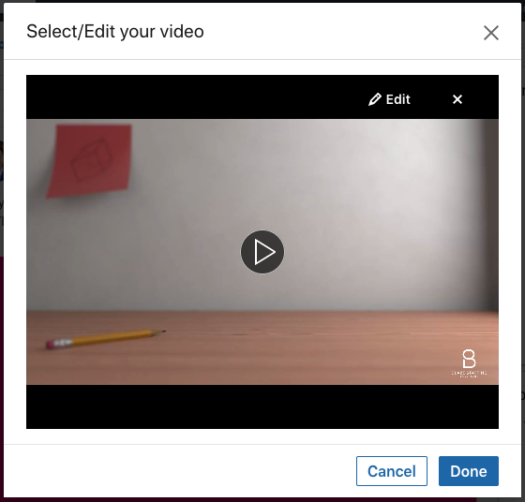

- Click on ‘Video Caption File (SRT Only)’, a new window will appear, find and select the SRT file and click upload.
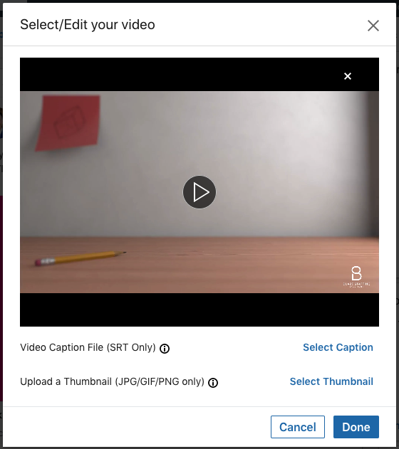
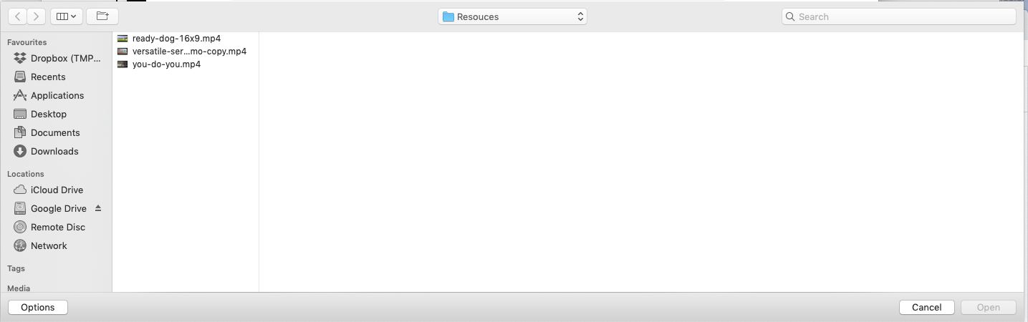

- You will see the file has uploaded under the heading ‘Video Caption File (SRT Only)’, Click 'Done' to finalise the process.
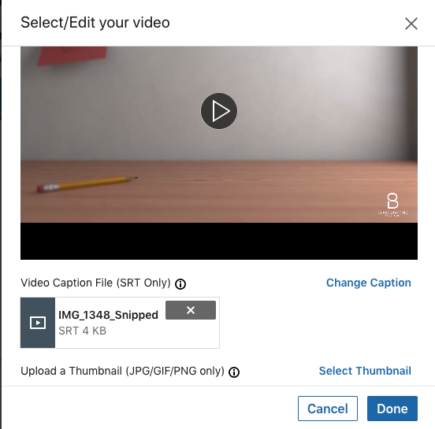

- Once this is complete, add your accompanying copy before posting to the profile.
