Write & format a LinkedIn text post

THE DETAILS
These are the essentials you need to know before you start writing your post.

Image: Are you going to use an image? If so, what is it?

Publish date/time: Think about your publish date and time. When is your audience likely to be browsing LinkedIn? Look at how people have engaged with your previous posts to determine this.

Link: Are you linking to a blog or your website? You need to know exactly where you’re linking to so that you can guide your audience towards it in your post.

Character limit: 3000 characters (including spaces) for LinkedIn posts. This also includes your link, if you add it to the main post (more on that below).

TO CONSIDER
Extra touches that will make your post more engaging and get it in front of more people.

Hashtags: Are there any industry-specific or broader hashtags you can use? Add these to the bottom of your post, or if they fit naturally you can include them throughout.

Formatting: LinkedIn posts are easier to read when each sentence is its own paragraph. Your audience will only see your first line while scrolling through the feed - the rest is hidden. Make sure that first line is enticing enough to make people click the ‘see more’ button.

Link: You can share your link in the comments rather than in the body - recent tests have shown that this helps your post be seen by more people. Keep in mind however that social media networks often change their algorithm - so always look out for the latest research.

Emoji: Although LinkedIn is a more professional environment, consider using emojis to draw attention where appropriate.

Tags (@): Are there any relevant business pages or people that could be tagged to increase exposure?

Examples:

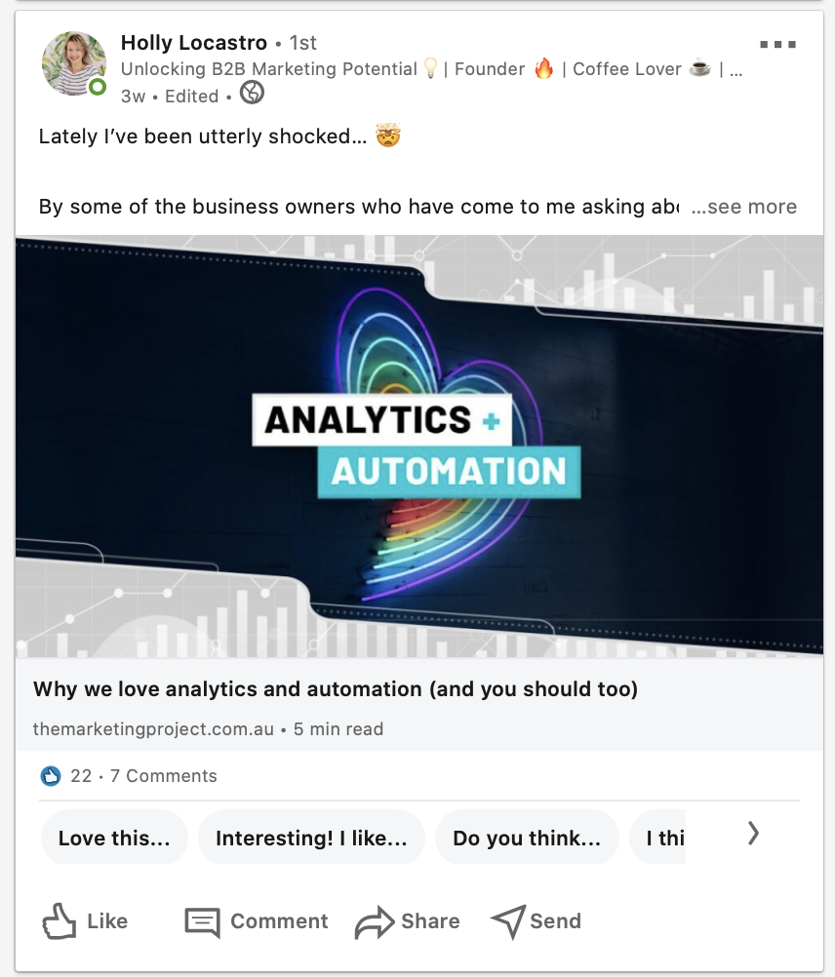

An example of an eye-catching opening line.

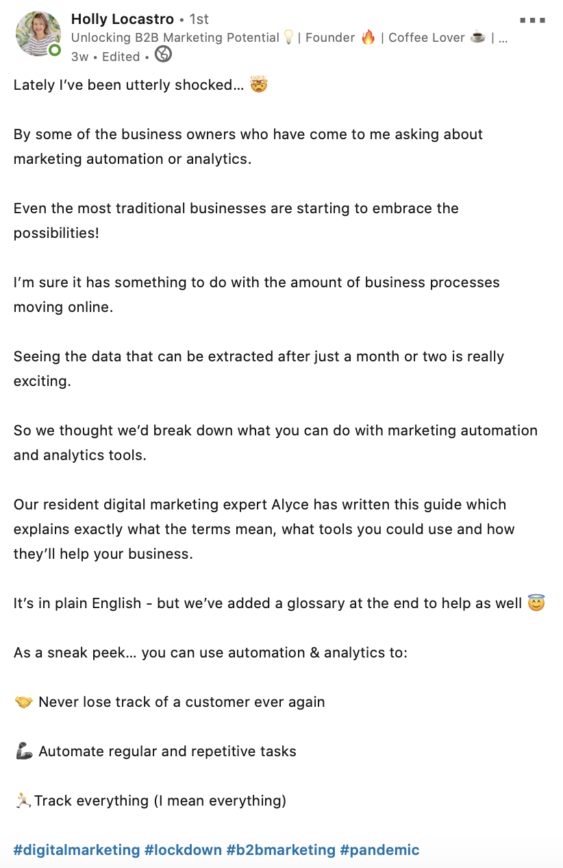

The full post. Note the line spacing, hashtags and use of emojis in place of dot points.
Last updated May 2024

