# Social Media Scheduling Walkthrough

Rather than always needing to be online when it’s time to post, it’s much more efficient to use scheduling software to ‘pre-schedule’ your social media posts in batches or whenever it’s convenient for you. There are many paid and free options available, each with different levels of functionality – take some time to decide which is right for you (or send us a note and we can help).

This checklist will show you how scheduling works, and what you need to check off before you can start. We’re using [Buffer](http://www.buffer.com/) in these examples.

* *Log in to your preferred social media scheduling platform*
* *Select the correct social profile*

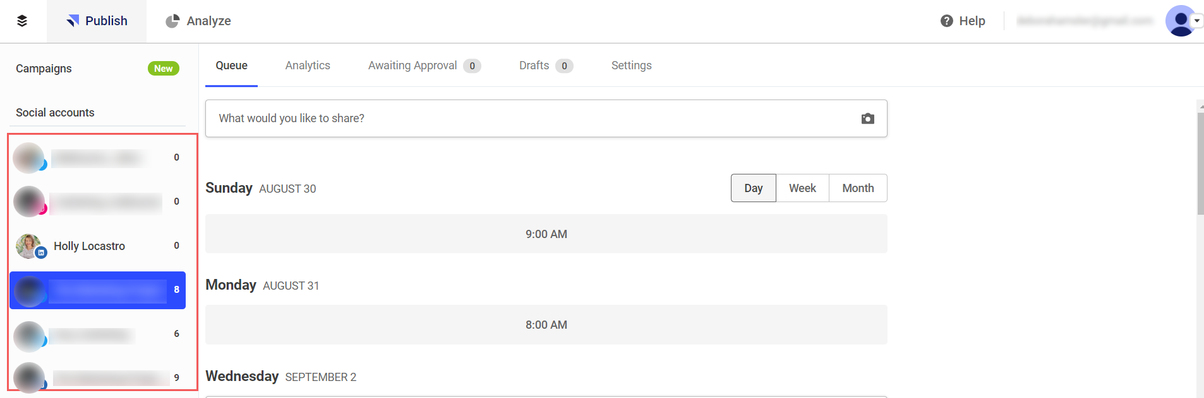

* *Hover over the set posting days/times and select ‘Schedule a Post’*

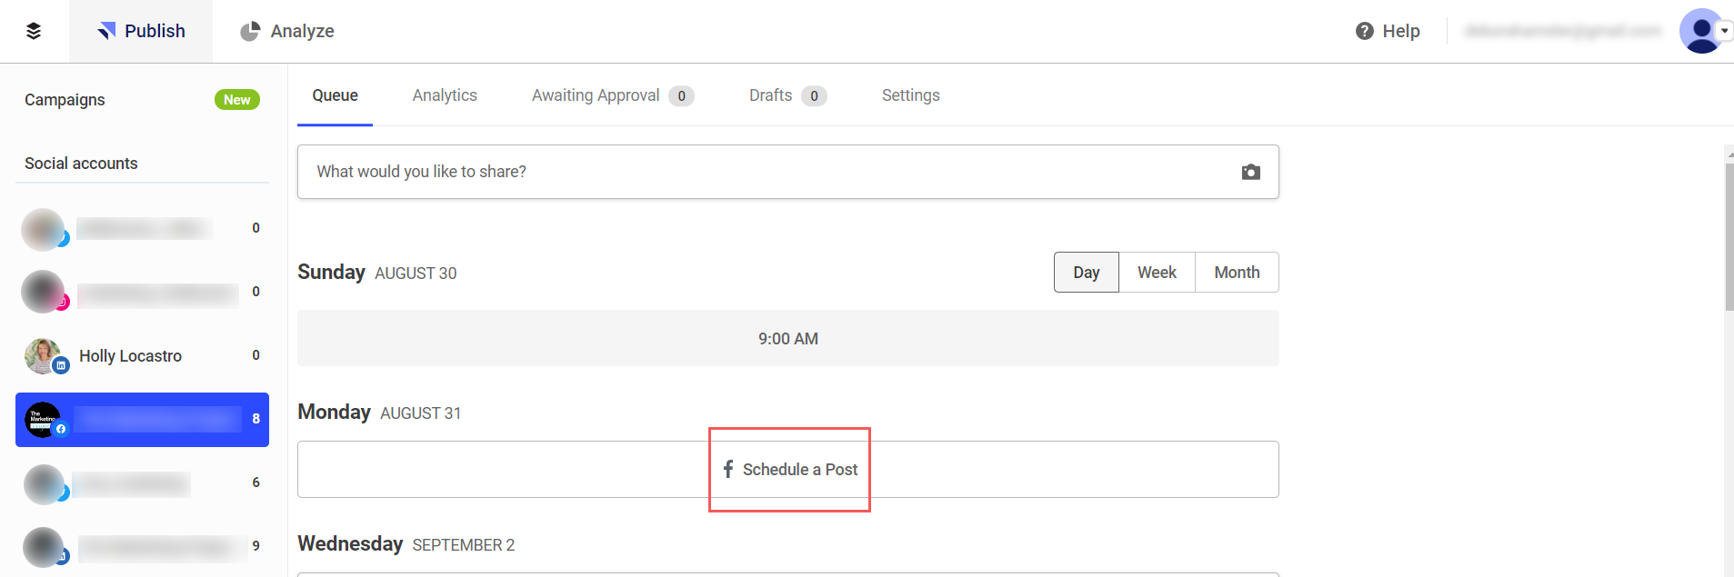

* *Paste copy into the post day/time. Note: if there is a link to a webpage generally it will be automatically shortened.   
  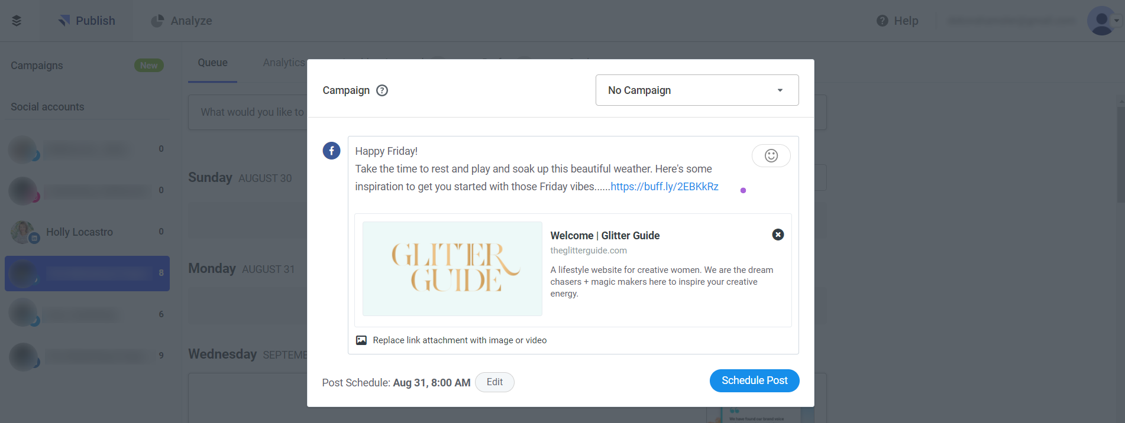*
* *If you’ve inserted a link, check the image has pre-populated (if there is one). Is it suitable for the content and has it formatted correctly? If you need to add or replace an image, delete the pre-populated one (if there is one) and attach your own. If you’re repurposing content (which we recommend) you’ll want to avoid using the same pre-populated image each time you promote the content/article.*

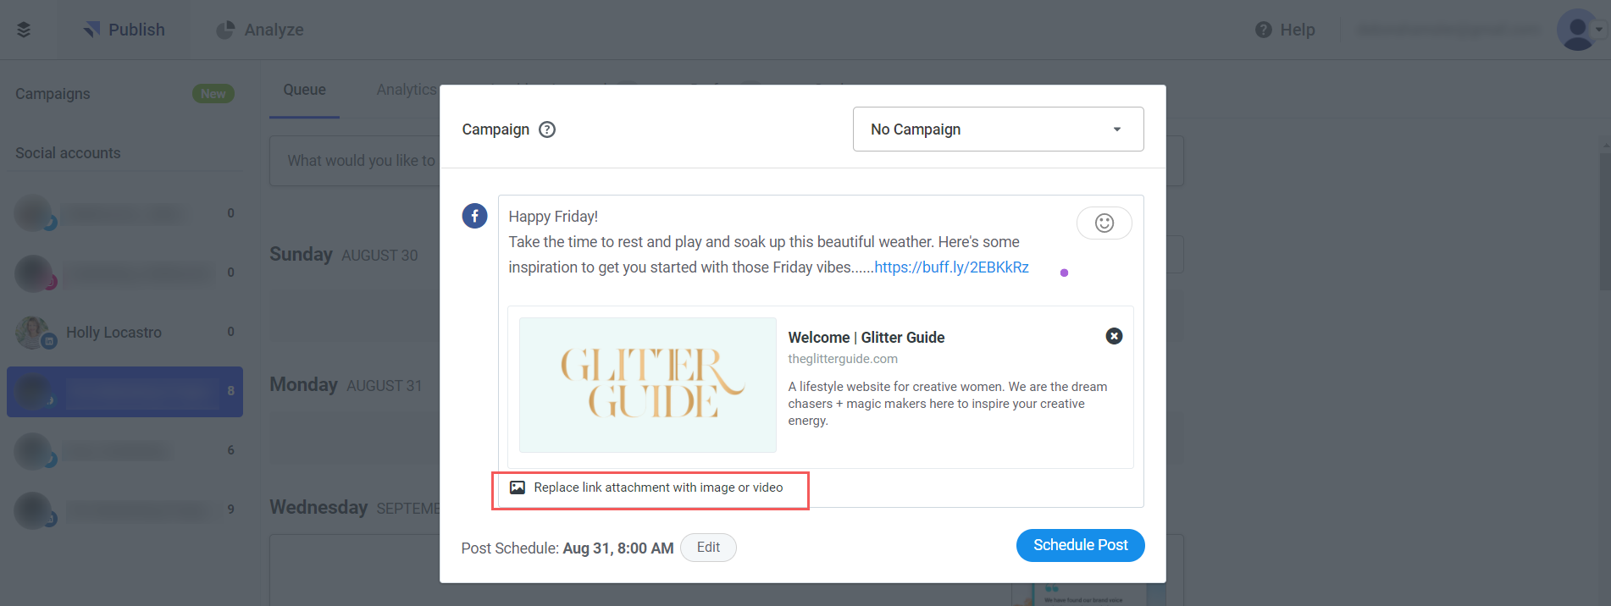

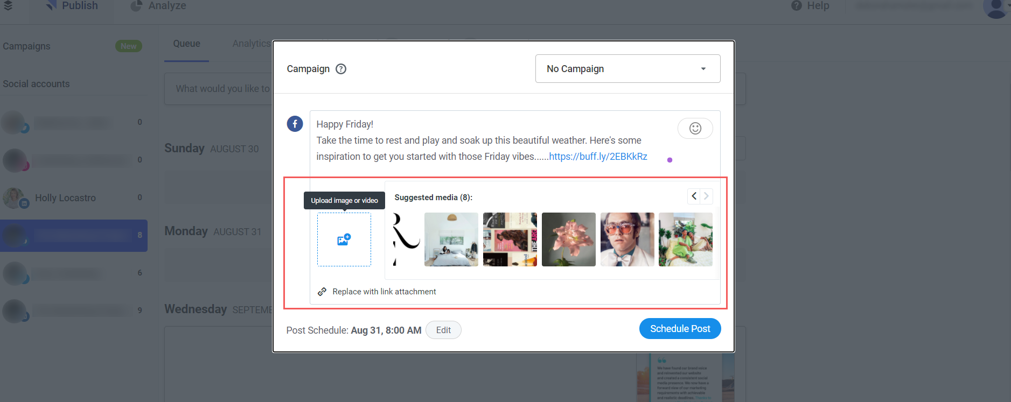

* *Review how your copy is presented and check you’ve included the relevant hashtags.*
* *Once you are happy with the image and content layout, click ‘Schedule Post’ button.*

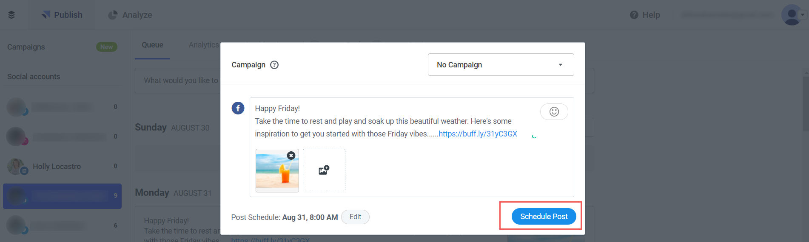

* *Your post is scheduled ready to go!*

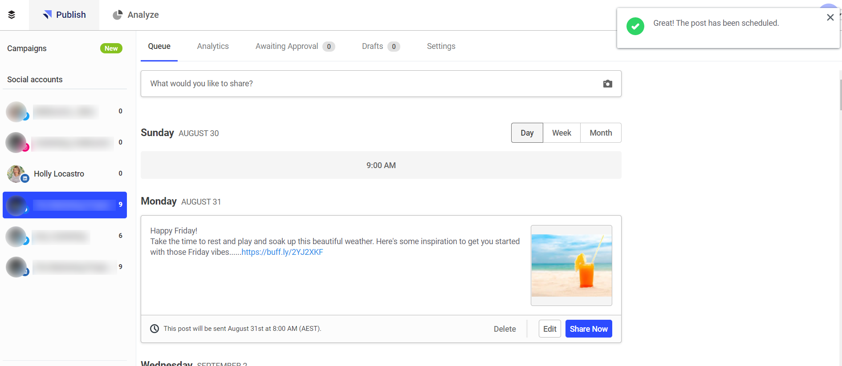

* *If you need to alter the date and/or time click the ‘Edit’ button and you can select what time/date you need.*

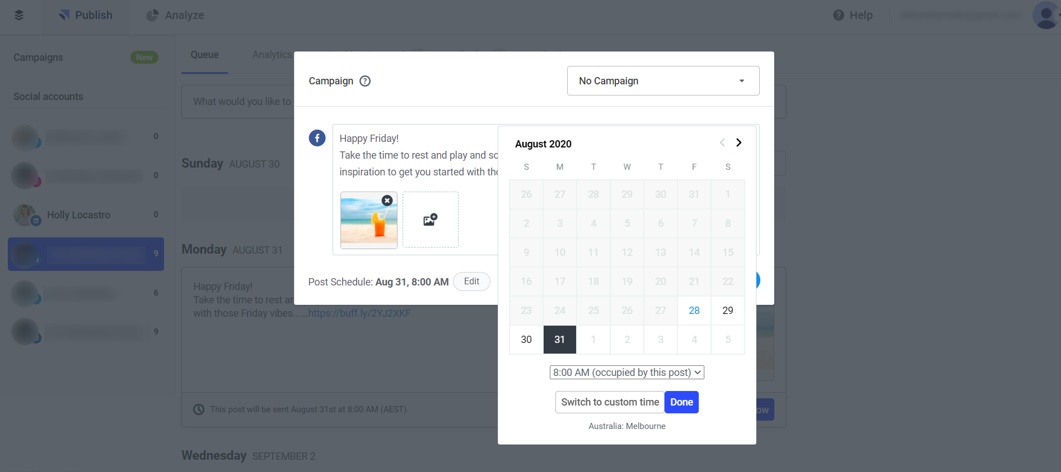

# Social Media Scheduling Checklist

Here’s what you need to double-check on every post before it goes out:

You’re posting to the right network (if using a scheduler)

The link works (and corresponds with the post)

No typos in the copy

Image is the right size for each channel

Spacing of the copy looks good (add breaks between each line)

Date and time are appropriate for posting

You have a good set of relevant hashtags

***Last updated February 2021***