**LinkedIn image size guide**

This guide gives the lowdown on the best image sizes for LinkedIn. This guide was last updated June 2024.

## Profile images

* The profile image can consist of any JPG or PNG.
* The image will be compressed upon upload to 400 x 400 px when displayed on the Profile page – but for best results use a larger, sharper original image. We usually use 850 x 850 px, so it will appear nice and large when clicked.
* The profile image will crop to a circle when viewed in the feed – so it’s important to consider how it will appear. Avoid placing important visual information in the corners, and if your design is circular (e.g. a circular logo) – make sure its edges sit on or within LinkedIn’s circular crop.

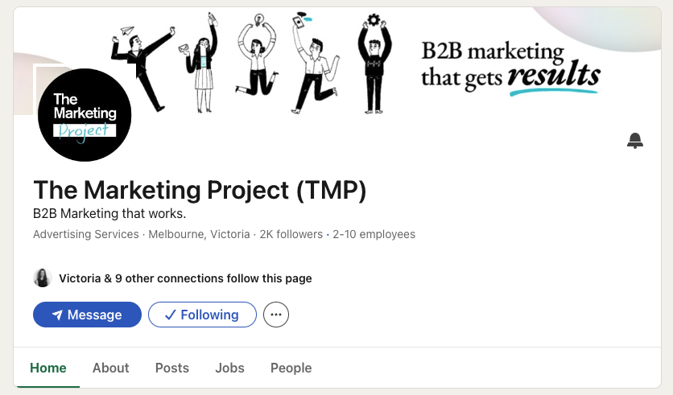

* When in the feed, the profile image appears at 40 x 40 px or even smaller, so consider legibility especially on small screens. If your image or logo is quite detailed or busy – it might be worth considering a “simplified” or icon version of the logo for your profile image.

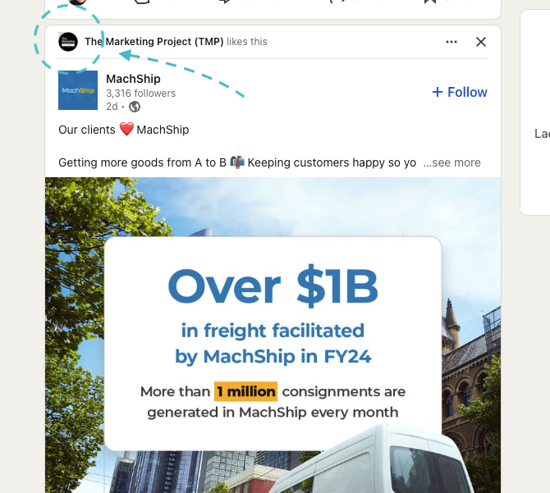

## Photo posts

* LinkedIn allows rectangle shaped images as standard (1200 x 628 px) and has recently begun allowing portrait images too (use a 1200px width, and adjust height as necessary).

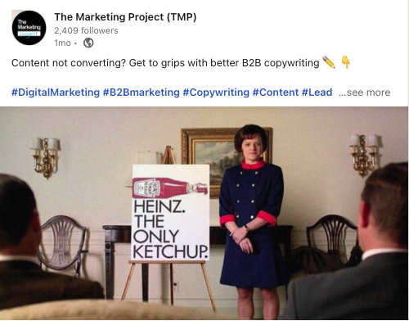

* LinkedIn also allows galleries, with individual images of any size. These will arrange differently depending on the amount of images - and as such makes it unsuitable for creating a unified design like you would with an Instagram carousel of images.

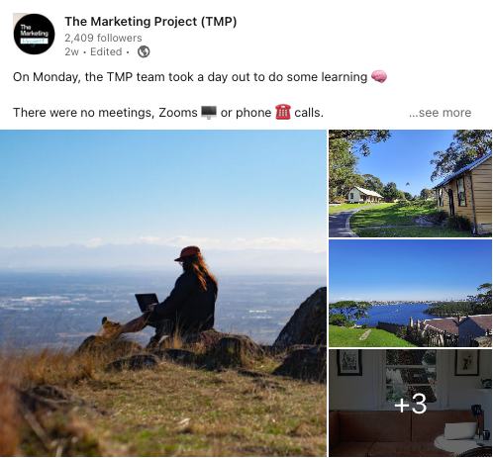

* Linked posts (with a URL) will pull through the image from the website – or you can also replace with a 1200 x 628 px image of your choice.

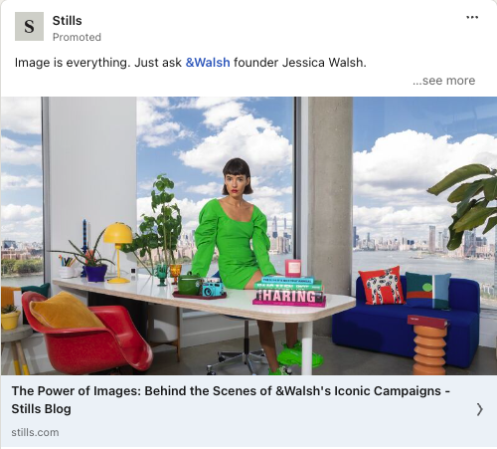

* LinkedIn Slides may also be utilised to tell a more cohesive story with images. Try uploading a deck or square-sized series of images, allowing users to browse as a carousel.

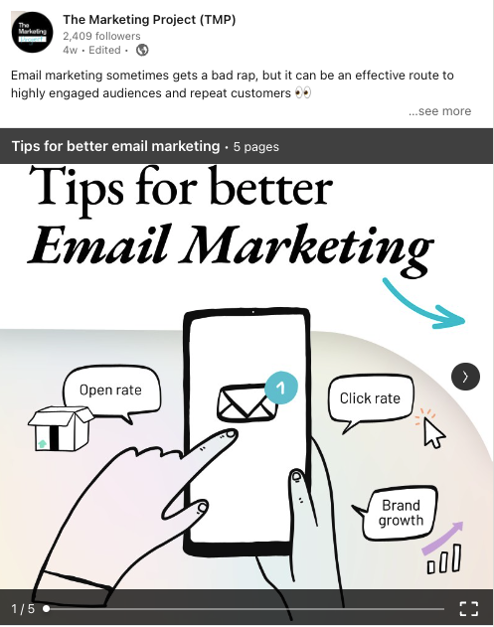

## Video posts

* LinkedIn allows MP4, MOV, or GIF files, up to 10 minutes in length.
* You can use portrait, square or landscape videos.
* Aim for 1920 x 1080 or higher resolution – and consider adding subtitles as most people viewing won’t view with sound (easiest to upload as a .SRT)



## Cover images

### LinkedIn (company) page

* LinkedIn accepts JPG and PNG files as cover images.
* The space for cover on company pages is very wide, and not very tall – normally displayed at 1128 x 191 px.
* We recommend a large image to preserve as much detail as possible: 2256 x 382 px.
* Consider the impact of the Profile picture overlapping the cover image – ensure no text or important information appears on the bottom left (this is different on Desktop VS Mobile).



### Personal profile page

* LinkedIn accepts JPG and PNG files as cover images.
* Covers on personal profiles are still quite wide but slightly deeper – normally displayed at 1584 x 396 px.
* The profile image will also overlap the cover image here – so be cautious not to lose any important visual information behind it.

